Bivalent verb classes across Slavic: areal and genealogical patterns
Abstract. The Slavic languages, with their intricate history of genealogical divergence and extensive language contact, provide a rich context for exploring the interplay between genealogical and areal influences on the evolution of valency class systems. These systems, characterized by their diachronic instability, are shaped by both internal linguistic dynamics and external factors. Drawing on data from BivalTyp, a typological database of bivalent verbs and their encoding frames (www.bivaltyp.info), this study analyzes the valency properties of 130 bivalent predicates (e.g., ‘hit’, ‘know’, ‘be afraid’, ‘look’, ‘resemble’) across 11 Slavic standard varieties: Russian, Belarusian, Ukrainian, Polish, Czech, Slovak, Slovenian, Croatian, Serbian, Macedonian, and Bulgarian. The dataset is annotated for valency-encoding devices, such as cases and adpositions, as well as for cognacy relations between verbs and argument-encoding markers. These annotations facilitate the construction of distance matrices that reveal patterns of similarity and divergence among Slavic languages in various subsystems of argument encoding, with syntactic dimensions partially independent of the cognacy relations of the verbs involved. The findings highlight the significant role of areal factors in shaping valency patterns in Slavic languages, often surpassing genealogical influences. This is evident in the systematic convergence between Polish and East Slavic languages and in broader areal trends, where Slavic languages exhibit syntactic convergences with neighboring non-Slavic languages.
Keywords. Valency pattern, Slavic, transitivity, language contact, typological database.

1. Setting the stage

Slavic languages display variation in the distribution of verbs across valency classes, as shown by examples (1) from Serbian and (2) from Czech.

(1) Petar se stidi svoj-e visin-e
PN[NOM.SG] REFL shame.PRS.3SG one’s-GEN.SG.F height(F)-GEN.SG
‘Petar is embarrased about his height.’ (BivalTyp)

(2) Petr se stydí za svoj-i mal-ou postav-u
PN[NOM.SG] REFL shame.PRS.3SG for one’s-ACC.SG.F small-F.ACC.SG stature(F)-ACC.SG
‘Petr is embarrassed about his small height.’ (BivalTyp)

The two sentences have nearly identical meanings, use cognate (reflexive) verbs, and are syntactically similar, but differ in the coding of non-subject arguments: (1) uses the genitive case, while (2) employs the preposition za ‘for’ with the accusative case. Both coding strategies exist in the two languages, but the verbs stiditi se ‘to feel embarrassed’ in Serbian and stydět se in Czech are assigned to different valency classes.
While (1) and (2) illustrate mismatches, Slavic languages often share valency patterns. For instance, the Slovak equivalent of (1) and (2) use za and the accusative, aligning with Czech, although the verb hanbiť sa is etymologically unrelated. The genitive pattern appears in Slovenian, Polish, and all East Slavic languages, aligning syntactically with Serbian in (1), even when the verbs involved are not cognate with Serbian stiditi se, compare Polish wstydzić się, Slovenian sramovati se, and Russian стесняться.
Finally, Bulgarian and Macedonian differ superficially from other Slavic languages, using the prepositions от (Bulgarian) or од (Macedonian), as shown in (3) for Macedonian.

(3) Петар се срами од свој-от раст
PN[NOM.SG] REFL shame.PRS.3SG from one’s-ART.SG.M height(M)
‘Petar is embarrased about his height.’ (BivalTyp)

However, at a higher level of abstraction, Bulgarian and Macedonian align with the genitive pattern: both have lost their nominal case systems, with от/од largely filling the genitive’s functional niche. Thus, the pattern in (3) is the closest Macedonian counterpart to the genitive in other Slavic languages.
This introduction highlights the fact that differences in how verbs are assigned to valency classes in Slavic languages may relate to etymological relationships but are not solely determined by them. While major morphosyntactic changes, like the loss of nominal cases in Eastern South Slavic, affect valency-coding, they do not automatically alter valency class structure. Crucially, the observed synchronic similarities and differences are not random but reflect genealogical and areal affinities shaped by historical processes. Building on this, my analysis aims to quantitatively assess valency class similarities and differences across Slavic languages and interpret them as evidence of genealogical and areal influences.
The goals and methods of my study are similar to those of the recent work by Seržant et al. (2022). Both studies are grounded in the same theoretical premises outlined above but rely on independent datasets and apply different quantitative methods. In the following discussion, when the two studies yield similar results, I consider this to be mutual reinforcement of their validity, but I place particular emphasis on the results presented in my study that are not found in Seržant et al.’s (2022) work.
The remainder of this paper is organized as follows. Section 2 outlines key concepts relevant to cross-linguistic research on valency classes. Section 3 presents the dataset. In Section 4, I describe the methods employed to assess (dis)similarities between systems and discuss the main empirical results. Section 5 summarizes the study and offers a brief outlook on broader issues.

2. Definitions and key concepts
The valency of a verb is commonly understood as “the list of its arguments with their coding properties” (Malchukov et al. 2015: 30). Valency serves as a bridge between the semantic dimension, where the verb’s arguments bear semantic roles and the morphosyntactic dimension.
Cross-linguistically, argument-coding devices include flagging (cases and adpositions), indexing (verb agreement), and word order (Malchukov et al. 2015: 31; Sinnemäki 2008: 68). In Slavic languages, flagging is the key component of argument-coding systems. For instance, the Polish valency pattern in (4) can be exhaustively described as a combination of arguments in the nominative and instrumental cases, with the verb automatically indexing the nominative argument.

(4) Paweł macha chustk-ą
PN[NOM.SG] wave.PRS.3SG handkerchief-INS.SG
‘Paweł is waving a handkerchief.’ (BivalTyp)

Two verbs belong to the same valency class if their arguments are coded by the same combination of argument-coding devices. Thus, the Polish verb in (5) belongs to the same valency class as the verb in (4).

(5) Paweł gardzi Magd-ą
PN[NOM.SG] despise.PRS.3SG PN-INS.SG
‘Paweł despises Magda.’ (BivalTyp)

Flagging devices in Slavic include cases (4)-(5), prepositions (3), or their combinations (2). The same preposition used with different cases constitutes distinct coding devices. Thus, the Slovenian verbs uživati ‘enjoy’ and zaljubiti se ‘fall in love’ in (6) and (7) belong to distinct valency classes.

(6) An-a uživa v čaj-u
PN-NOM.SG enjoy.PRS.3SG in tea-LOC.SG
‘Ana enjoys hot tea.’ (BivalTyp)

(7) Peter se je zaljubi-l v An-o
PN[NOM.SG] REFL AUX.3SG fall_in_love-LPT[M.SG] in PN-ACC.SG
‘Peter fell in love with Ana.’ (BivalTyp)

The concept of valency has been central to syntactic research for decades (Apresjan 1967; Fillmore 1968; Lazard 1994; Levin 1993; Croft 1998; Malchukov & Comrie, eds., 2015; Ruppenhofer et al. 2016), including studies of Slavic languages (Apresjan, Páll 1982: 42-43; Janda, Clancy 2002; Zolotova 2006; Lyashevskaya, Kashkin 2015). Despite differing approaches and terminologies, two points of consensus emerge.
On the one hand, verbs with similar meanings often display similar valency behavior (Apresjan 1965; Fillmore 1968, Helbig & Schenkel 1983: 62-63; Jackendoff 1990: 246-251, Levin 1993: 1-10; Blume 1998). This suggests that verbs in the same valency class, as in examples (4) and (5), may also share semantic similarities.
On the other hand, valency patterns are not equally motivated by verb meanings. Case assignment mechanisms range from general rules that assign “structural” cases (e.g., nominative and accusative) (Lazard 1994: 134-135; Dowty 1991) to mid-range mappings between semantic roles (e.g., Recipient) and specific coding devices (e.g., the dative), to idiosyncratic cases linked to individual verbs (Yip et al. 1987; Woolford 2006; Barðdal 2011: 645-648; Haspelmath 2014: 5).
While default case assignments are crucial for alignment typology (Haspelmath 2011), cross-linguistic differences in valency class organization are most evident in non-default case assignments (Bickel et al. 2014; Gaszewski 2020: 17). To identify significant differences among Slavic languages, which share the same basic morphosyntactic profile, a large list of verb meanings is required (Seržant et al. 2022; Gaszewski 2020).
Similarities in valency class organization within genealogical taxa can result from common ancestry and preservation (Rostovtsev-Popiel 2024). In contrast, dissimilarities always arise from diachronic processes affecting valency, as shown for Slavic languages, among others (McAnallen 2011; Seržant et al. 2022). Various mechanisms of such change have been identified (Pinkster 1988; Seržant, Kulikov (eds.) 2013; Luraghi, Roma (eds.) 2021), including studies on Slavic material (Samardžija 1994; Ovsjannikova 2011; Milković in prep.). Two scenarios are particularly relevant here: analogy and valency-copying.
Analogy is a system-internal process where a verb adopts a new valency pattern based on similar verbs in the same language (Lazard 1994: 148; Troberg 2008). For example, in Russian, the instrumental used with poražatʹsja ‘be astonished’ is being replaced by the dative, influenced by verbs like udivljat’sja ‘be surprised’. Ultimately, this change was triggered by a semantic drift from a concrete meaning like ‘be stricken’ to a more abstract meaning; see Ovsjannikova, Say (2020) for details.
Valency-copying is a partially system-external process in which a verb in a target language adopts a new valency pattern based on a corresponding verb in the donor language (Grossman & Witzlack-Makarevich 2019). It is a subtype of pattern replication, a situation when inherited resources are used to copy an external model (Matras, Sakel 2007). A notable example is the use of the transitive pattern for predicative possession (‘to have’) in some Slavic languages, often considered a calque from Greek. McAnallen (2011) offers a detailed reevaluation of this view, but still emphasizes the decisive role of language contact in shaping the distribution of predicative possessive constructions across Slavic languages. While valency-copying can occur in both related and unrelated languages, distinguishing it from parallel development is particularly challenging in genealogically related languages.
Changes in a verb’s valency pattern can be accompanied by lexical renewal, which may occur either system-internally (when a verb or its derivative acquires a new meaning) or system-externally (when a verb is borrowed). However, lexical and syntactic changes are generally independent. For example, a change in meaning may or may not lead to a change in valency (Samardžija 1994), and borrowed verbs may either retain the donor language’s valency pattern or assimilate themselves to the target system (Grossman & Witzlack-Makarevich 2019). While verb borrowing is infrequent, valency patterns are highly susceptible to language contact, accounting for the areal distribution of valency phenomena (Say 2014; Grossman, Witzlack-Makarevich 2019; Trips 2020; Kim 2020; Alfimova 2024; Khachaturyan et al. 2025).
The processes outlined above form the basis for both divergent and convergent changes in valency within closely related languages such as the Slavic languages. While a qualitative, diachronic approach would involve tracing individual verbs in diachronic corpora to identify specific changes, this paper adopts a quantitative, synchronic approach to systematically measure and analyze similarities and differences in modern Slavic languages’ valency behavior, aiming to infer the contributions of various diachronic processes to their valency patterns. To carry out this research, a consistently annotated dataset of valency patterns observed in modern Slavic languages was needed, as discussed in the next section.

3. Dataset
The dataset for this study, accessible at [LINK REMOVED], is derived from the publicly available BivalTyp database (Say, ed., 2020–), with additional annotations. The database documents bivalent patterns in a large sample of languages and is based on elicited material from a questionnaire. The target clauses focus on meanings that typologically favor non-transitive structures (see Seržant et al. 2022 for a similar approach) and often include contextual information in parentheses, e.g., #13: ‘(P. and M. played chess.) P. beat M.’ (where “P.” and “M.” are placeholders for person names). The two arguments in the target clauses, such as ‘P. beat M.’, are labeled as X and Y, with X representing the argument that accumulates more “proto-agent” properties (Dowty 1991).
Each database entry is based on a language-specific translation of a questionnaire clause into a target language. For convenience, I use English verbs to refer to parallel database entries (e.g., ‘win’ for #13). However, the 130 questionnaire sentences are designed as probes in an infinite semantic space, not as a representative sample of verbs. The ‘sentence-list-based’ approach advances the ‘wordlist-based’ typologies (Nedjalkov 1969; Bossong 1998; Nichols et al. 2004; Malchukov, Comrie, eds., 2015). By focusing on sentences rather than verbs, BivalTyp sacrifices scope (130 sentences per language cover only a fraction of possible bivalent structures) but enhances comparability, as parallel entries convey the same contextualized meanings.
The analysis below is based on the latest development version of the BivalTyp database, available as of February 12, 2025 and covering 139 languages, primarily from Northern Eurasia. Table 1 lists the 11 Slavic languages included in the BivalTyp sample (data from other languages were used for comparative purposes, as detailed below).

Table 1. The Slavic languages in the dataset
language | branch | contributor
Russian | East Slavic | Sergey Say*
Belarusian | East Slavic | Volha Harytskaya*
Ukrainian | East Slavic | Natalia Zaika
Polish | West Slavic | George Moroz
Czech | West Slavic | Anastasia Makarova
Slovak | West Slavic | Martin Gális*, Kirill Kozhanov
Slovenian | South Slavic | Andreja Žele*, Mladen Uhlik*
Croatian | South Slavic | Mislav Benić*
Serbian | South Slavic | Anastasia Escher
Macedonian | South Slavic | Vladimir Fedorov, Maria Khazhomia
Bulgarian | South Slavic | Krasimira Petrova*

The dataset includes 1,420 Slavic entries, slightly fewer than the expected 1,430 (130 per 11 languages) due to 10 gaps, representing a negligible missing data rate of approximately 0.7%. The gaps result from missing translations or translations that do not meet the inclusion criteria, such as requiring both X and Y arguments to appear as clause-level dependents.
All entries in the dataset are annotated for five parameters: i) verb lemma, ii) valency pattern, iii) locus, iv) verb cognacy set, and v) valency pattern cognacy set. The first three annotation fields are inherent in the BivalTyp database and were used in this study without further modification.
Verb lemma is the citation form of the “valency carrier” (Gaszewski 2020) used as the predicative head in the entry, which is typically a simplex verb, but may be, e.g., an adjective or a complex verb. In (8), the Slovak translation of questionnaire sentence #13, the verb lemma is vyhrať.

(8) Peter vyhra-l nad Mark-om
PN(M)[NOM.SG] win(PFV)-PST[M.SG] above PN(M)-INS.SG
‘Peter beat Marek.’ (BivalTyp)

Valency pattern is the main response variable, defined as the ordered combination of coding devices for X and Y. The valency pattern in (8) is schematically represented as “NOM_nadINS”, meaning X is coded by the nominative case, and Y by the preposition nad ‘above’ combined with the instrumental case.
A BivalTyp entry is classified as transitive, with the exceptional valency class label “TR”, if its two core arguments align morphosyntactically with the ‘killer’ and ‘victim’ micro-roles of the verb ‘kill’ in the same language; see Haspelmath (2015: 136) for a similar approach. In most Slavic languages, this involves the X argument in the nominative case and the Y argument in the accusative case. In Bulgarian and Macedonian, which lack morphological case on nouns, the transitive pattern is defined by i) both X and Y being unflagged by prepositions, ii) the X argument indexed by verb agreement suffixes, and iii) the Y argument optionally doubled by an accusative proclitic. Thus, the Macedonian entry in (10) is considered transitive as it matches the morphosyntactic pattern of ‘kill’ in (9).

(9) Петар ја уби-Ø Маја
Petar PRO.3SG.ACC.F kill:PFV-3SG.AOR Maja
‘Petar killed Maja.’ (BivalTyp)

(10) Петар ја победи-Ø Маја
Petar PRO.3SG.ACC.F win:PFV-3SG.AOR Maja
‘Petar beat Maja.’ (BivalTyp)

Locus (of non-transitivity) is a four-way variable that indicates whether the two pre-defined arguments are coded by direct or oblique devices, with “direct” referring to the strategies used for the core arguments in the transitive pattern. The four possible values of locus are “TR”, “X”, “Y”, and “XY”. “TR” is used for transitive entries, where both arguments are coded by direct devices. An entry has Y-locus if X is coded as the subject (or rarely, as the direct object), and Y is coded by an oblique device. Y-locus patterns are common in the Slavic dataset, see (1)-(8). The less common X-locus, illustrated by the Croatian example (11), occurs when X is coded by an oblique device, and Y by a direct device (typically the nominative case).

(11) Per-i se sviđa ta košulj-a
PN-DAT.SG REFL like.PRS.3SG this.NOM.SG.F shirt-NOM.SG
‘Pero likes this shirt.’ (BivalTyp)

Finally, XY-locus represents the rarest possibility in the dataset. The Polish equivalent of entry #56, ‘be short’, featuring the verb brakować and the “DAT_GEN” pattern, is an example.
The notion of locus is grounded in two principles. First, it aligns with Malchukov’s (2006) “relevance principle”, which states that syntactic non-transitivity is overtly coded on the constituent deviating from high semantic transitivity (Hopper and Thompson 1980). Slavic data generally supports this: X-locus is typical of verbs with less agentive X arguments, such as verbs of emotion (11), and Y-locus of verbs with less affected Y arguments. Second, unlike the valency patterns per se, which are language-specific descriptive categories (Haspelmath, Hartmann 2015; Gaszewski 2020: 22), the four-way distinction of locus is a comparative concept in the sense of (Haspelmath 2010). As such, locus is a suitable tool for comparing how languages map semantic features onto syntactic patterns, even across unrelated languages.
The remaining two annotation parameters are not part of the BilvalTyp database and were additionally annotated for the Slavic dataset in this study.
Verb cognacy sets capture whether the verbs involved in language-specific entries are etymologically related. For example, the 11 Slavic equivalents of entry #25 ‘think’ fall into two sets: 1) Russian думать, Ukrainian думати, Belarusian думаць; 2) Polish myśleć, Czech přemýšlet, Slovak rozmýšľať, Slovenian razmišljati, Croatian misliti, Serbian мислити, Macedonian мисли, Bulgarian мисля. Cognacy sets are based solely on roots, ignoring affixal differences (see also Orestova 2018). This broad approach ensures a discrete definition of verb cognacy, avoiding arbitrary decisions in borderline cases.
Finally, valency pattern cognacy sets capture whether the language-specific equivalents of a given entry share “the same” valency pattern. While valency patterns are language-specific, in Slavic languages they can usually be equated based on the shared etymologies of case forms and prepositions. For the annotations, I used pan-Slavic tags, assigning different tags only when valency patterns in two languages could not plausibly result from the continuous development of the same Common Slavic pattern (see Khachaturyan et al. 2025 for a similar procedure regarding Mande languages). Table 2 illustrates this principle for the 11 equivalents of entry #37 ‘(M. did something very stupid. Now,) P. is making fun of M.’ The caseless patterns in Bulgarian and Macedonian are tagged as “NOM_nadINS,” aligning them with the pattern found in Russian. Phonological differences in cognate prepositions are also disregarded in the annotations.

Table 2. Equivalents of entry #37 ‘make fun’ and their valency patterns
language | sentence | valency pattern | cognacy set
Russian | Петя издевается над Машей | NOM_nadINS | NOM_nadINS
Belarusian | Алесь здзекуецца з Алены | NOM_zGEN | NOM_sGEN
Ukrainian | Петро знущається з Марії | NOM_zGEN | NOM_sGEN
Polish | Mefistofeles drwi z Boga | NOM_zGEN | NOM_sGEN
Czech | Petr se vysmívá Michalovi | NOM_DAT | NOM_DAT
Slovak | Peter si z Marka robí žarty | NOM_zGEN | NOM_sGEN
Slovenian | Peter se norčuje iz Pavla | NOM_izGEN | NOM_sGEN
Croatian | Pero se ruga Miši | NOM_DAT | NOM_DAT
Serbian | Петар малтретира Марију | TR | TR
Macedonian | Петар се потсмева над Маја | SBJ_nad | NOM_nadINS
Bulgarian | Петър издевателства над Михаил | SBJ_nad | NOM_nadINS

While Slavic languages with six-term case systems (excluding the vocative, which is irrelevant for my goals) allow for straightforward cognacy set annotations, the caseless languages, Bulgarian and Macedonian, pose challenges. I used the following annotation schema for these two languages.
i) The pattern characterized by the lack of flagging and the optional use of the accusative clitic was equated with the nominative plus accusative transitive pattern elsewhere.
ii) Many Bulgarian and Macedonian verbs can combine with a dative clitic and/or a lexical argument noun phrase flagged by the preposition на ‘on’, as in Bulgarian examples (12) and (13). Macedonian differs from Bulgarian in that the dative clitic is obligatorily used in constructions with lexical argument noun phrases as well.

(12) Петър вярва нa Мария
PN believe:IPFV.3SG.PRS on PN
‘Petar believes Mikhail’. (BivalTyp)

(13) Петър й вярва
PN PRO.3SG.DAT.F believe:IPFV.3SG.PRS
‘Petar believes her’. (Krasimiria Petrova, p.c.)

For language-internal purposes, BivalTyp uses complex tags like “SBJ_DAT(na)” for verbs exemplified in (12) and (13), but for this study, I equated these valency patterns with the “NOM_DAT” pattern observed elsewhere.
iii) For all other patterns involving prepositions, the Bulgarian and Macedonian patterns are analyzed using the same case labels as other Slavic languages, as discussed for the preposition над based on the data in Table 2.
The annotation of valency pattern cognacy sets is logically and empirically independent of the verb cognacy set, as shown by the four equivalents of entry #29 in Table 3. Here, the Polish verb is cognate with only the Czech verb, while the Polish valency pattern is cognate with only the Russian pattern.

Table 3. Verb and valency cognacy relations: four equivalents of entry #29 ‘forget’
language | sentence | cognacy set
 |  | verb | valency pattern
Russian | Петя забыл о другой дороге | zabyt’ | NOM_oLOC
Polish | Basia zapomniała o tej drodze | zapomnieć | NOM_oLOC
Czech | Petr zapomněl na tu druhou cestu | zapomnieć | NOM_naACC
Slovenian | Peter je pozabil na pot | zabyt’ | NOM_naACC

Two remarks of caution concerning the possible limitations of my dataset are required.
First, BivalTyp focuses on bivalent verbs and does address argument coding in verbs of other valency types. However, bivalent verbs are ideal for exploring cross-linguistic differences in valency classes, as they tend to display non-canonical patterns and also form valency classes that are relatively stable cross-linguistically (Bickel et al. 2014).
Second, BivalTyp ignores variability within languages, such as cases where a verb can be used in different valency patterns with or without a clear change in propositional content. While it provides guidelines for choosing between patterns, much information is lost, and the final choices are sometimes arbitrary. The discrepancy between the Serbian and Croatian patterns in Table 2 likely results from the data-gathering process rather than reflecting a substantial difference between the languages. However, these drawbacks are outweighed by BivalTyp’s advantages, such as large lexical coverage and semantic consistency. While some differences may be spurious, cross-linguistic similarities, especially those aligning with genealogical or areal distinctions, are less likely to be so, as discussed in Section 4.

4. Distance metrics and results
My main goal was to measure, using the dataset outlined in Section 3, differences between Slavic languages in verb cognacy (4.1), valency pattern cognacy (4.2), locus distributions (4.3), and lexical distributions of verbs into valency classes (4.4). Despite varying distance metrics, I calculated pairwise distances between languages for all four aspects (0 = maximal similarity, 1 = maximal dissimilarity) and analyzed the resulting matrices. All calculations were performed in R (R Core Team 2021) using the following packages: dplyr (Wickham et al. 2023), ggpubr (Kassambara 2023), infotheo (Meyer 2022), lingtypology (Moroz 2024), lmerTest (Kuznetsova et al. 2017), readxl (Wickham and Bryan 2023), and writexl (Ooms 2024). The R code and distance matrices are available at [LINK REMOVED].

4.1. Verb cognacy
To measure etymological dissimilarities in verb usage between the compared languages, I introduced DistVerbEtym, a metric based on the normalized Hamming distance and verb cognacy annotations. It was calculated as the ratio of entries with verbs from distinct cognacy sets. Table 4 illustrates this method with verb lemmas from 10 entry pairs in the Russian and Polish datasets.

Table 4. Verb cognacy relations in the Russian and Polish datasets
No | predicate | Russian | Polish | Distance
42 | forfeit | лишиться | stracić | 1
43 | try to catch | ловить | łapać | 1
44 | break | сломать | złamać | 0
45 | flatter | льстить | pochlebiać | 1
46 | love(1) | любить | kochać | 1
47 | wave | махать | machać | 0
48 | dream | мечтать | marzyć | 1
49 | wash | вымыть | umyć | 0
50 | put on | надеть | włożyć | 1
51 | be called | называться | nazywać się | 0

In the toy example in Table 4, DistVerbEtym for Russian and Polish is 0.6, calculated as 6 etymological mismatches divided by 10 entries. For the full datasets, DistVerbEtym is 0.57 (74 mismatches out of 130 entries).
After calculating DistVerbEtym for all pairs of the 11 Slavic languages in my sample, I obtained a distance matrix that largely aligns with the accepted Slavic genealogy, especially at the micro-level. The smallest DistVerbEtym values are observed for Belarusian–Ukrainian (0.22), Serbian–Croatian (0.22), Slovak–Czech (0.28), and Bulgarian–Macedonian (0.34). These pairs represent closely related languages, with Croatian and Serbian arguably being two standards of the same language.
However, there are also similarities cutting across accepted genealogical branches. The 5th and 6th shortest distances are between Polish and Ukrainian (0.37), and Polish and Belarusian (0.38). Hierarchical clustering, which produces a dendrogram from the distance matrix, groups Polish, Belarusian, and Ukrainian into a cluster that excludes other languages (see Fig. 1).
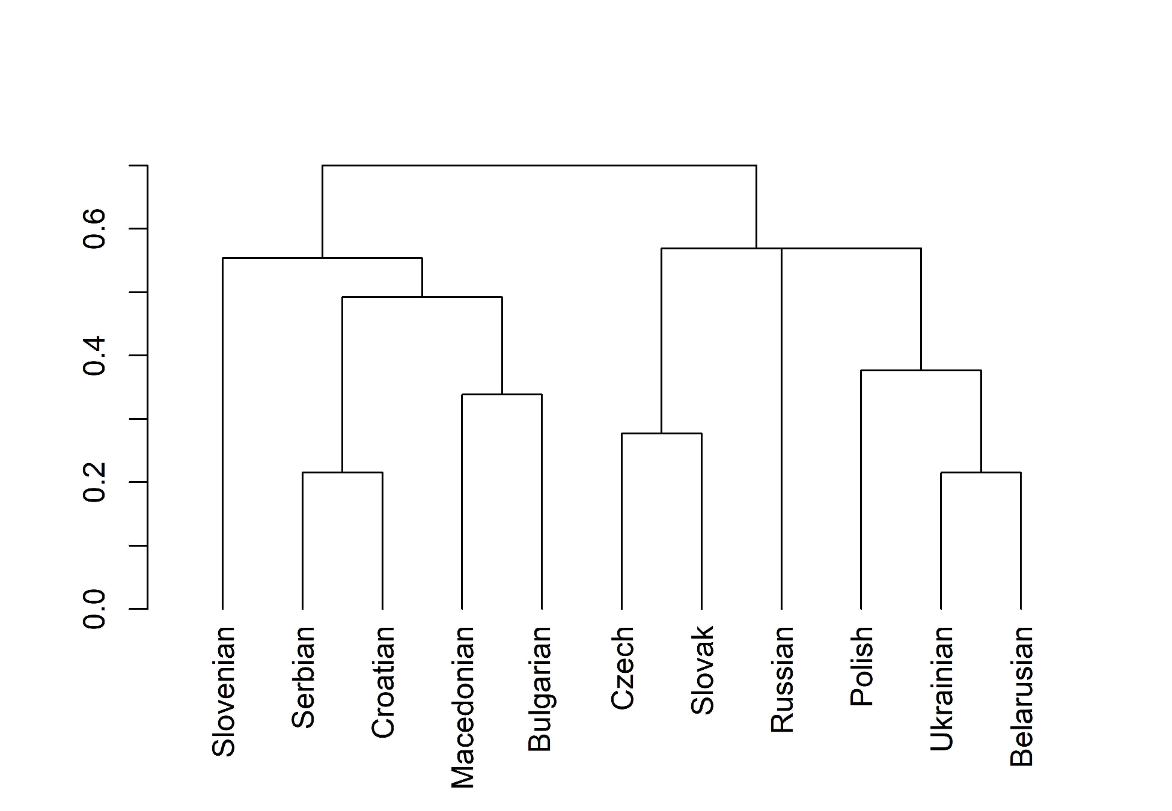
Fig. 1. Dendrogram based on DistVerbEtym

The empirical basis for the Polish-Ukrainian-Belarusian cluster is evident in the raw data. For instance, 14 entries contain cognate lexical predicates in Polish, Ukrainian, and Belarusian that are not found in other datasets, see Table 5.

Table 5. Cognate verbs unique to Polish, Ukrainian, and Belarusian
No | predicate | Polish | Ukrainian | Belarusian
2 | ‘have (illness)’ | chorować | хворіти | хварэць
18 | ‘hold’ | trzymać | тримати | трымаць
30 | ‘depend’ | zależeć | залежати | залежаць
39 | ‘look for’ | szukać | шукати | шукаць
42 | ‘forfeit’ | stracić | втратити | страціць
48 | ‘dream’ | marzyć | мріяти | марыць
52 | ‘punish’ | ukarać | покарати | пакараць
58 | ‘like’ | podobać się | подобатися | падабацца
64 | ‘be different’ | odróżniać się | відрізнятися | адрознівацца
79 | ‘hit (target)’ | trafić | потрапити | трапіць
98 | ‘agree’ | zgodzić się | згодитися | пагадзіцца
113 | ‘fall in love’ | zakochać się | закохатися | закахацца
116 | ‘envy’ | zazdrościć | заздрити | зайздросціць
127 | ‘get upset’ | zasmucić się | засмутитися | засмуціцца

The verbs in Table 5 are heterogenous. The equivalents of ‘to have (illness)’, ‘punish’, and ‘agree’ share a common Slavic etymology (Derksen 2008); cognates exist in other Slavic languages but are absent from the BivalTyp database due to semantic divergence or lack of neutrality. The equivalents of ‘hold’ and ‘look for’ emerged in Old Polish and were later borrowed into Old Ruthenian (Brückner 1985/1927). Regardless of the specific scenarios for individual verbs, the Polish-Lithuanian Commonwealth, where the ancestors of modern Polish, Belarusian and Ukrainian were spoken, likely played a key role in shaping the discussed lexical similarities.
The DistVerbEtym metric is based on the lexicostatistic method also used in glottochronological studies, which typically focus on basic vocabulary considered stable and resistant to borrowing. In contrast, the BivalTyp questionnaire includes many non-basic lexical items, likely explaining the deviations in the dendrogram in Fig. 1 compared to the canonical Slavic cladistic tree. However, Polish being grouped with (some) East Slavic languages is not unprecedented (Bouckaert et al. 2012, Rama 2018). In fact, Kassian (2023) partially attributes the distortions in the tree presented in Bouckaert et al. (2012) to their misclassifying Polish loanwords in Ukrainian as inherited. While this is a flaw in a glottochronological study, my goal is different: to explore lexical and syntactic similarities and differences between Slavic languages in the context of their known genealogical relationships. In this regard, the convergence between Polish, Ukrainian, and Belarusian is a reliable finding.
Convergences between genealogical taxa are better captured by networks than trees. One common algorithm for building such networks is NeighborNet, implemented in the SplitsTree4 software (Huson and Bryant, 2006). A NeighborNet visualization of the same distance matrix based on DistVerbEtym is shown in Fig. 2.
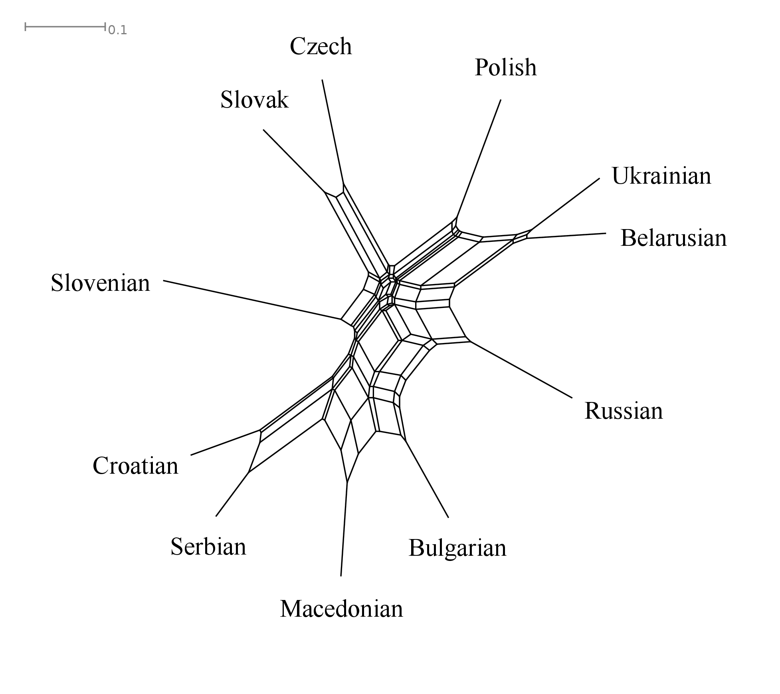

Fig. 2. NeighborNet visualization of the DistVerbEtym distances

An important aspect of interpreting the NeighborNet visualization is identifying splits, represented by sets of parallel edges of equal length. In this regard, the inspection of Fig. 2 confirms all the generalizations made from the dendrogram in Fig. 1, while also adding two new ones.
First, although Bulgarian and Macedonian are closely related, Bulgarian displays some lexical convergences with East Slavic languages when Macedonian patterns with Serbian (and, to a slightly lesser extent, Croatian). This split is seen in 8 dataset entries: #17 ‘tell’, #20 ‘milk’, #57 ‘hate’, #76 ‘remember’, #80 ‘cut oneself’, #101 ‘shoot at’, #110 ‘respect’, and #122 ‘have a grudge’ (in two further entries, #42 ‘forfeit’ and #59 ‘need’, Bulgarian patterns with Russian, but not the other two East Slavic languages). The reverse pattern, where Macedonian shares a lexical item with East Slavic languages and Bulgarian with Serbian or other South Slavic languages, is absent.
Second, Slovenian is the most divergent Slavic languages, not forming robust clusters with any other Slavic language. This echoes findings from previous lexicostatistic studies, see Kassian (2023) for a discussion.

4.2. Valency pattern cognacy
To measure etymological dissimilarities in valency patterns, I introduced DistValEtym, a metric similar to DistVerbEtym, based on the relative Hamming distance. The difference is that DistValEtym calculates the ratio of etymological mismatches in the use of valency patterns (not verbs), as indicated in the “valency pattern cognacy set” annotations in the dataset. For example, there are 26 entry pairs where Polish and Ukrainian use etymologically non-cognate valency patterns, yielding a DistValEtym value of 0.203 (= 26/128).
While the distance matrices based on DistVerbEtym and DistValEtym are similar, the DistValEtym value is consistently smaller than the DistVerbEtym value for every language pair, with average values of 0.32 and 0.55 respectively. This means that when comparing a random entry from language L1 to its counterpart in another Slavic language L2, the likelihood of finding an etymologically unrelated verb is 0.55, whereas for valency patterns it is only 0.32. This suggests that valency patterns are diachronically more stable than the verbs (see Alfimova in prep. for the same conclusion based on the Baltic data).
The two dimensions of potential diachronic change are not fully independent. The incidence of non-identical valency patterns for cognate verbs (0.25) is significantly lower than for non-cognate verbs (0.39), as confirmed by the paired t-test (t = 4.7, p=6.12×10⁻⁶). See Orestova (2018) for similar calculations based on a smaller dataset. However, these values also suggest that verb cognacy is not the primary factor determining whether Slavic languages exhibit parallel syntactic patterns for a given verb meaning.
In Fig. 3, the distance matrix based on DistValEtym is visualized using the same NeighborNet algorithm introduced in Section 4.1.

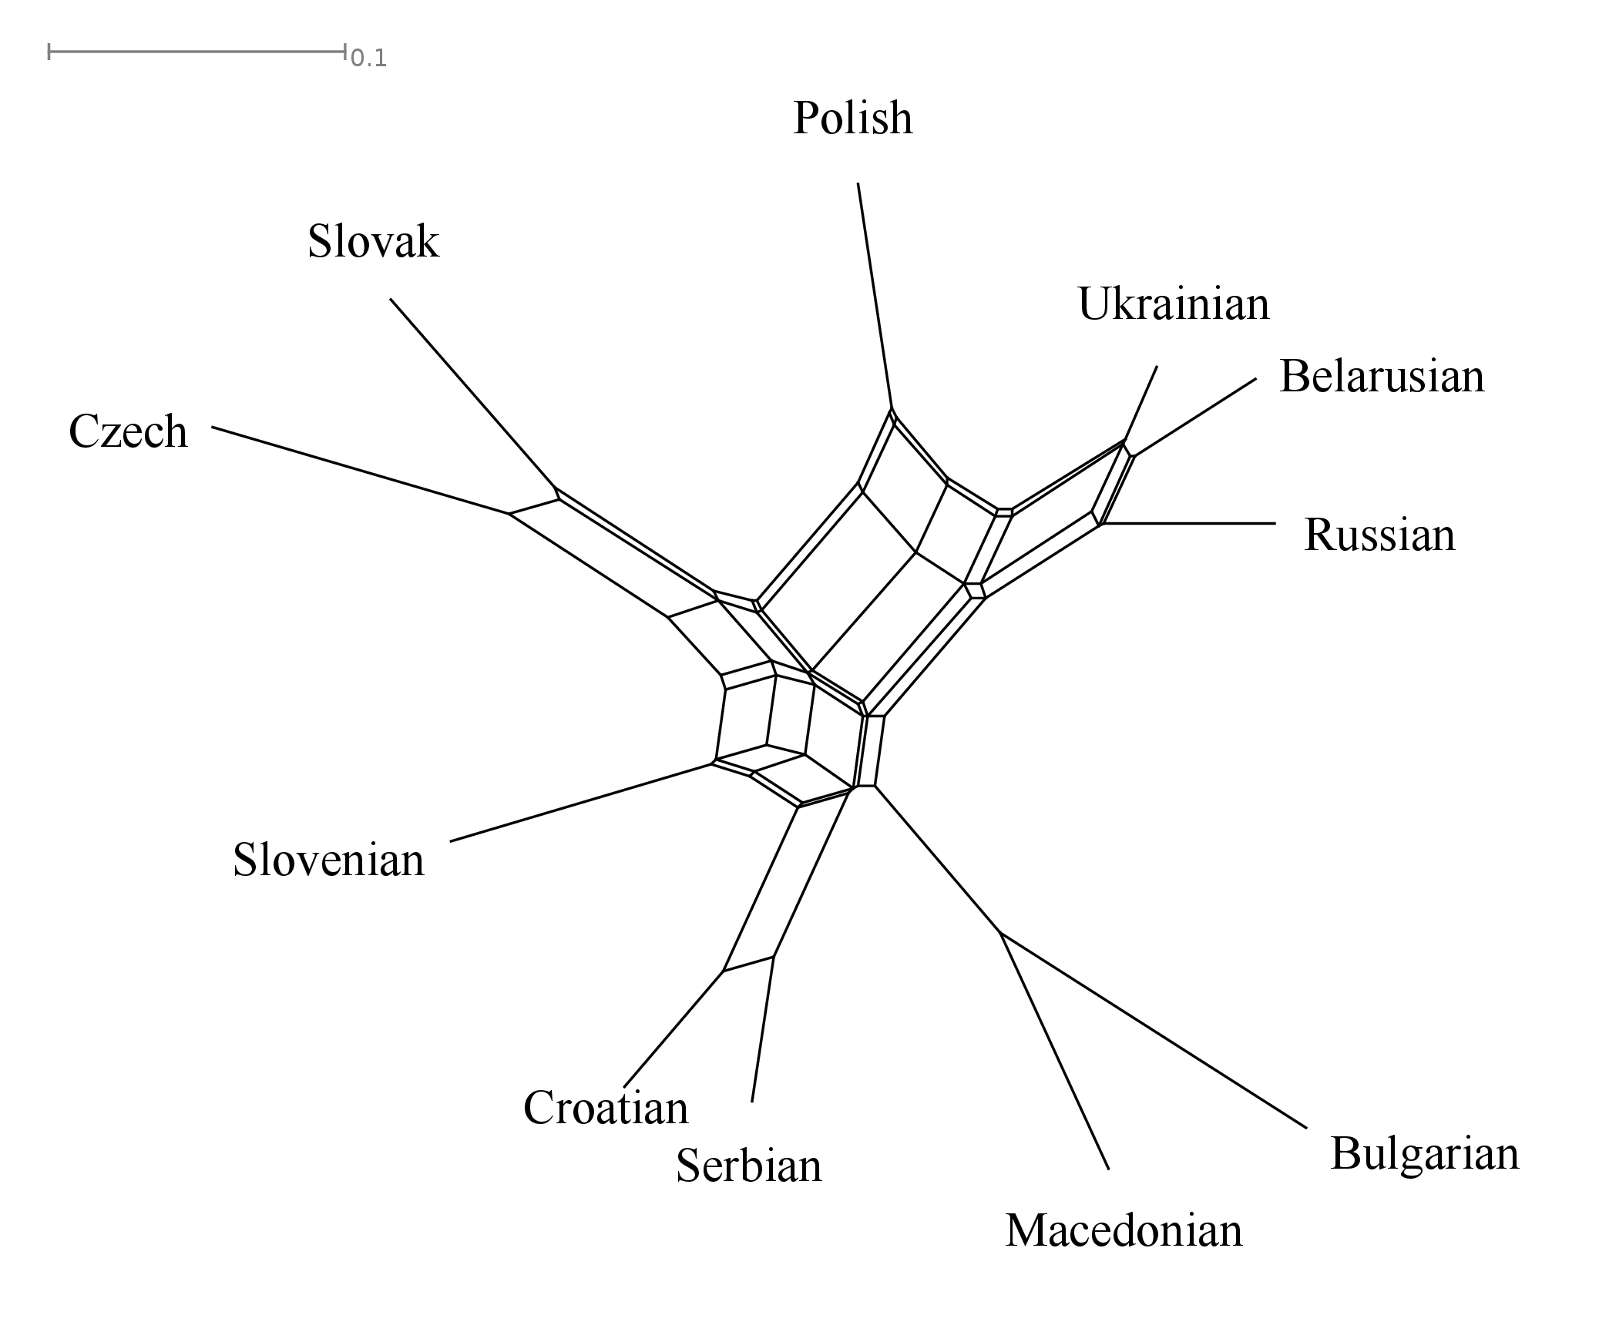

Fig. 3. NeighborNet visualization of the DistValEtym distances

The network in Fig. 3 resembles the dendrogram in Seržant et al.’ (2022: 323), which was built using similar methods but an independent dataset. This similarity supports the validity of both studies, especially the generalization that genealogical relationships strongly predict similarities in valency patterns, see also Alfimova (2024: 293). With this in mind, I will highlight some observations that are not evident in Seržant et al.’s (2022) findings or my discussion in Section 4.1.
i) Eastern South Slavic languages form a tightly-knit cluster, with neither Bulgarian nor Macedonian showing systematic exceptional affinities to languages outside this group. Specifically, unlike in Fig. 2, there are no connections between Macedonian and Serbo-Croatian or between Bulgarian and East Slavic languages. The loss of the nominal case likely accounts for the development that made Macedonian and Bulgarian equidistant from other Slavic languages in terms of their valency patterns.
ii) While the visualization in Fig. 3 confirms the close resemblance between Polish and East Slavic languages, as discussed by Seržant et al. based on their dendrogram (2022: 323-325), it also adds important nuances due to its reticular organization.
First, the Polish–East Slavic connection is robust but layered, with especially strong similarities between Polish, Ukrainian, and Belarusian. My raw data yield an almost exceptionless generalization: if Polish shares a valency pattern with Russian (but not Czech), then this pattern is also observed in Ukrainian and Belarusian (though the reverse is sometimes not true). Seržant et al. (2022) debate whether the Polish–East Slavic similarities are driven mainly by the convergence in the Polish–Ukrainian–Belarusian zone, or by Polish’s relationships with all three East Slavic languages, and ultimately favor the latter. My data, as visualized in Fig. 3, suggest this dichotomy is unnecessary: while some patterns are shared by Polish, Ukrainian, and Belarusian alone, others are shared by Polish and all East Slavic languages.
Second, apart from valency pattern similarities with East Slavic languages, Polish also shares similarities with the remaining West Slavic languages, as reflected in Fig. 3. This connection is exemplified by the valency patterns of dotknąć ‘touch’ with the prepositionless genitive case; czekać ‘wait’ with the preposition na plus accusative; or boleć ‘hurt, ache’ with the experiencer in the accusative and the body part in the nominative, all of which are not attested in East Slavic datasets (although they may exist in broader usage).
To summarize, areal convergences across taxa are best captured by networks like the one in Fig. 3, where Ukrainian and Belarusian lie between Russian—the remaining East Slavic language—and Polish; Polish is between the remaining West Slavic languages and East Slavic languages; Slovenian is between the remaining South Slavic languages and West Slavic languages (especially Czech and Slovak), etc.

4.3. Locus distinctions
Compared to specific verbs and valency patterns, the distribution of verb meanings by locus is relatively stable across Slavic languages. For example, equivalents of #1 ‘feel pain’ consistently show the X-locus (with the experiencer in a non-subject position), while #6 ‘resemble’, #7 ‘believe’, and #47 ‘wave’ consistently display the Y-locus. Many entries, such as #9 ‘see’, #18 ‘hold’, and #41 ‘bite’, remain consistently transitive across Slavic languages. However, locus-based differences exist, as shown in Table 5 with the equivalents of #97 ‘dream (sleeping)’, a rare case where all four locus values are present.

Table 5. Slavic equivalents of #97 ‘(P. sleeps.) P. dreams of M.’ and their locus
language | sentence | locus
Russian | Пете снится Маша | X
Belarusian | Алесю сніцца Алена | X
Ukrainian | Марії сниться Петро | X
Polish | Romanowi śni się Matka Boska | X
Czech | Petrovi se zdá o Michalovi | XY
Slovak | Peter sníva o Márii | Y
Slovenian | Peter je sanjal Devico Marijo | TR
Croatian | Pero sanja Mariju | TR
Serbian | Petar sanja Mariju | TR
Macedonian | Петар ѝ се сонува на Маја | Y
Bulgarian | Петър сънува Мария | TR

Table 6 summarizes aggregate differences in locus type prevalence across Slavic languages, ordered by decreasing ratio of transitive patterns, known as transitivity prominence (Haspelmath 2015).

Table 6. The prevalence of patterns defined in terms of locus
language | TR | Y | X | XY
Polish | 0.41 | 0.53 | 0.04 | 0.02
Russian | 0.42 | 0.52 | 0.05 | 0.02
Belarusian | 0.43 | 0.51 | 0.05 | 0.02
Ukrainian | 0.44 | 0.50 | 0.05 | 0.02
Czech | 0.45 | 0.49 | 0.05 | 0.02
Macedonian | 0.47 | 0.48 | 0.05 | 0.00
Slovak | 0.48 | 0.49 | 0.03 | 0.00
Croatian | 0.50 | 0.43 | 0.07 | 0.01
Serbian | 0.50 | 0.42 | 0.07 | 0.01
Slovenian | 0.50 | 0.43 | 0.06 | 0.01
Bulgarian | 0.52 | 0.43 | 0.04 | 0.01

Transitivity prominence declines from Polish and East Slavic languages to South Slavic languages, while the Y-locus, the most common intransitive type, displays the opposite areal trend (see the maps in the online version of BivalTyp). These findings, analyzed in detail by Seržant et al. (2022), will not be further discussed here.
Areal studies on valency patterns suggest that Standard Average European (SAE) languages favor uniform subject coding, while Slavic languages, on the SAE’s eastern periphery, more commonly feature non-canonical subjects, including experiencers (Faarlund 1998; Bossong 1998; Haspelmath 2001). As non-canonical subjects broadly correspond to X- and XY-locus patterns, the data in Table 6 align with this well-established generalization, showing these patterns across all Slavic languages.
The systematic differences in the prevalence of non-canonical subjects among Slavic languages are less clear. Bossong (1998) introduces a complex index for this prevalence, reporting values for Slavic languages as follows: Russian 2.11, Polish 0.88, Czech 0.76, Serbo-Croatian 0.75, and Bulgarian 0.48. Seržant et al. (2022: 319-322) find the highest prevalence of non-nominative subject-like arguments in East Slavic languages, especially Russian and Ukrainian, and the lowest in South Slavic languages, especially Bulgarian. My data in Table 6 show the highest prevalence of X- and XY-locus in Serbian and Croatian, followed by Slovenian, Czech, and the East Slavic languages. While all three datasets agree on some points, such as the low prevalence of X- and XY-locus in Bulgarian, they diverge on the placement of other languages, such as Polish and Serbo-Croatian.
Non-canonical coding of X arguments is typologically associated with a small set of predicate meanings, such as modal, possessive, cognition, sensation, emotion, and adversity impersonals. However, the extent of non-canonical subjects across these groups varies (Haspelmath 2001: 63-64; Say 2014: 144-145). The differences in the results discussed above likely stem from the arbitrary choice of diagnostic contexts used in each study. For instance, Seržant et al. (2022) is the only study among the three to include adversity impersonals, which are primarily found in East Slavic languages, resulting in higher scores for these languages. In contrast, BivalTyp includes an involuntary causative context (#86 ‘drop’), absent in the other studies. Only three languages in my dataset, Serbian (14), Croatian, and Macedonian, feature the X-locus for this context, contradicting the areal trend suggested by Seržant et al. 2022.

(14) Petr-u je ispa-la čaš-a
PN-DAT.SG be.PRS.3SG fall.down-PART.PERF.F.SG glass-NOM.SG
‘Petar dropped the glass.’

Cross-linguistic differences in the lexical extent of locus types are captured by DistValLoc, another metric based on relative Hamming distance. Calculated similarly to DistVerbEtym and DistValEtym, it uses the number of locus mismatches as the dividend. For example, the DistValLoc value for Russian and Polish is 0.12 (15 mismatches divided by 129 entry pairs without missing data). DistValLoc focuses on fundamental pattern differences and always yields values equal to or smaller than those of DistValEtym. Furthermore, lexical distributions of locus-determined patterns may be diachronically more stable than the specific argument-coding devices instantiating them (Rostovtsev-Popiel 2024: 70).
Unlike the first two metrics, DistValLoc applies to any language pair, regardless of genealogical relation. Fig. 4 shows a NeighborNet visualization of DistValLoc, comparing Slavic languages with several areally adjacent languages.
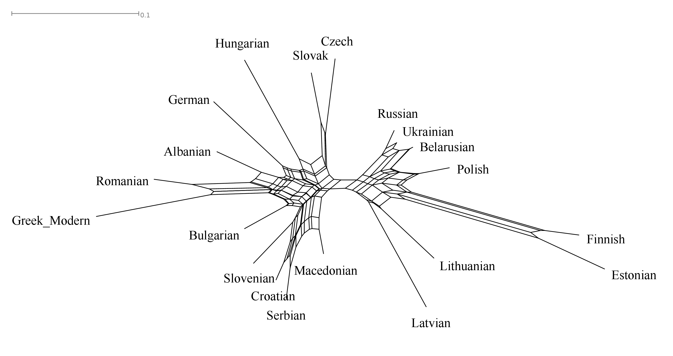

Fig. 4. NeighborNet visualization of DistValLoc distances among Slavic languages and select neighbors

The internal structure of Slavic languages as visualized in Fig. 4 is broadly consistent with findings reported in Section 4.2 and elsewhere (Seržant et al. 2022), showing Polish in close proximity to East Slavic languages, particularly Belarusian and Ukrainian, etc. Less expected are the connections between individual Slavic and non-Slavic clusters, likely influenced by areal factors. For example, there is a visible split placing Czech and Slovak with their Central European neighbors Hungarian and German, instead of other Slavic languages. This finding supports Alfimova’s observation that the Czech valency class system significantly deviates from all other Slavic systems (2024: 291). Additionally, East Slavic languages and Polish form part of a larger cluster with Baltic and Finnic languages, reflecting their complex contact history; see Alfimova (2024: 291-296) for a similar observation concerning Lithuanian (but not Latvian). Overall, the sensitivity of languages to specific semantic traits as triggers for locus selection appears to be easily transmissible through areal convergence.

4.4. Lexical composition of valency classes
The two distance metrics discussed in Sections 4.2 and 4.3 each have their advantages and disadvantages. DistValEtym reflects subtle differences in the lexical organization of valency classes but relies on etymological equivalence and cannot be applied to unrelated languages. DistValLoc, on the other hand, is applicable to unrelated languages but only captures fundamental syntactic distinctions and collapses distinctions coded by individual cases and adpositions.
Ideally, a metric combining the strengths of DistValEtym and DistValLoc is needed. The challenge is that valency classes in unrelated languages cannot be directly equated, which calls for alternatives to metrics based on relative Hamming distance. DistValPat, first introduced in Say (2014: 156) under a different label (“D”), addresses this by measuring dissimilarity in how two languages distribute verbs into valency classes without equating the classes themselves (see Gaszewski 2020 and Alfimova 2024 for alternative approaches to this problem). The starting point for calculating DistValPat in a language pair is a joint distribution, such as the fragment shown in Table 7 for Czech and German.

Table 7. A subset of German and Czech datasets and their joint distribution
No | predicate | German pattern | Czech pattern | joint distribution
23 | fight | NOM_mitDAT | NOM_sINS | NOM_mitDAT&NOM_sINS
24 | be friends | NOM_mitDAT | NOM_sINS | NOM_mitDAT&NOM_sINS
25 | think | NOM_anACC | NOM_oLOC | NOM_anACC&NOM_oLOC
26 | eat | TR | TR | TR&TR
27 | fry | TR | TR | TR&TR
28 | wait | NOM_aufACC | NOM_naACC | NOM_aufACC&NOM_naACC
29 | forget | TR | NOM_naACC | TR&NOM_naACC
30 | depend | NOM_vonDAT | NOM_naLOC | NOM_vonDAT&NOM_naLOC
31 | call | NOM_nachDAT | NOM_naACC | NOM_nachDAT&NOM_naACC
32 | get to know | TR | NOM_sINS | TR&NOM_sINS

As shown in Table 7, less systematic correspondences between valency patterns observed in the languages compared result in higher variation in the joint distribution. In a scenario with strict one-to-one correspondences, the joint distribution would mirror both language-specific distributions. Conversely, fully random correspondences would result in maximum variation in the joint distribution. The actual data always show an intermediate case. For example, Czech verbs with the “NOM_sINS” pattern are likely to correspond to German verbs with the “NOM_mitDAT” pattern; however, the correspondences are not perfect, as seen with the Czech “NOM_naACC” pattern. The quality of such matches can be quantified by Mutual Information (MI), a well-known metric based on Shannon’s entropy (H). The formula for H is given in (15).

(15) $H\left(x\right)=-\sum_{i=1}^{k}{p(x_{i})∙\log_{e}⁡(p\left(x_{i}\right))}$

In our case, values of x correspond to distinct valency classes observed in a given language (e.g., Czech) or in a joint distribution. Likewise, k is the number of possible patterns in a given language (for example, k equals 24 in the case of Czech). Finally, due to unavailability of actual probabilities of valency classes p(x_{i}), relative frequencies serve as estimates for these probabilities, which is a standard step in entropy-based approaches to linguistic phenomena (Ackerman and Malouf 2013: 439; Levshina 2019). In a nutshell, higher values of H correspond to more variable distributions.
As the next step, the formula for MI is given in (16).

(16) MI (X; Y) = H(X) + H(Y) – H(X, Y) (Hausser, Strimmer 2009)

Higher MI values occur when the entropy of the joint distribution is moderate, which happens when the two distributions are well-matched. By contrast, low MI values, with a theoretical minimum of 0, occur when the two distributions show fully random correspondences. As the final step, MI is converted into the distance metric DistValPat using the formula in (17).

(17) DistValPat (L1, L2) = 1$-\frac{\frac{MI (L1, L2)}{H (L1)} +\frac{MI(L1, L2)}{H(L2)} }{2}$

Like the previous distance metrics, DistValPat varies between 0 and 1, with higher values indicating greater differences between languages. Fig. 5 shows a NeighborNet visualization of DistValPat, featuring the same languages as Fig. 4.

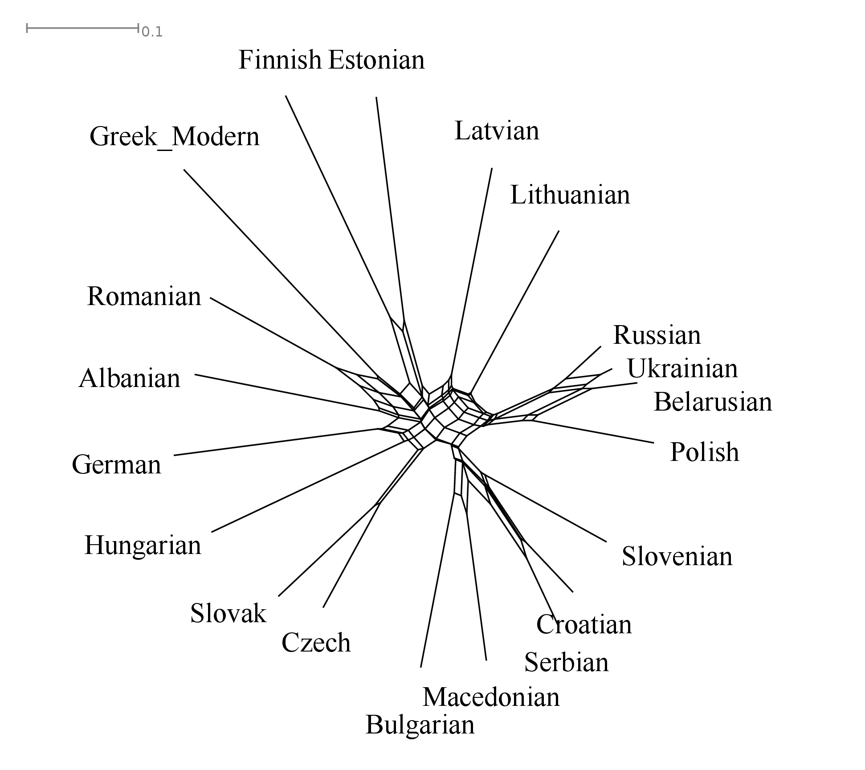
Fig. 5. NeighborNet visualization of DistValPat distances among Slavic languages and select neighbors

Fig. 5 closely resembles Figs. 3 and 4, particularly in its depiction of the internal structure of Slavic languages. This is expected, as all three visualizations reflect the same underlying valency pattern distribution, differing only in how (dis)similarities are measured. However, Fig. 5 also reveals new insights. Notably, unlike Fig. 4, it shows a split separating Slavic and non-Slavic languages. At the same time, local convergences persist, linking specific Slavic and non-Slavic languages. One example is the cluster including Baltic languages, Polish and East Slavic languages. Another is the cluster with Czech, Slovak, Hungarian, and German. This latter case arguably reflects the so-called Donaubund, a set of languages with multiple specific convergences in argument coding, which however are not strong enough to reshape the whole system of bivalent classes (Gaszewski 2020).
Overall, the DistValPat metric primarily captures strong similarities in valency class organization, not occasional calques affecting small parts of the verbal lexicon. This applies to convergent phenomena within Slavic languages, typically seen in small local clusters. Examples include Croatian and Serbian, Czech and Slovak, the Polish–East Slavic cluster (or, more precisely, two overlapping clusters: one with the three East Slavic languages and another with Polish, Ukrainian, and Belarusian), and the Eastern South Slavic cluster. Interestingly, despite shared features like tense organization or the lack of nominal case, Bulgarian and Macedonian still differ significantly in their verb distributions across valency classes, as seen in the long edges associated with these two languages in Fig. 5.

5. Summary and outlook
My analysis aimed to uncover similarities and differences in the distribution of bivalent verbs and their argument-coding patterns across 11 Slavic languages, contextualized within the broader areal background of Eastern and Central Europe. Instead of separating lexical and syntactic dimensions (Gaszewski 2020: 37), I employed an aggregate approach, combining both. This approach assumes that while the lexical-etymological distribution of verb roots is logically independent from the syntactic distribution of valency patterns, empirical correlations may exist. The observed synchronic distributions in the dataset shed light on diachronic processes shaping the Slavic linguistic landscape.
My first overarching finding is summarized in (18).

(18) The various aspects in the organization of bivalent verbs and their valency patterns display largely consonant distributions across Slavic languages.

Aligning with (18), similarities in valency structures are observed at all levels in pairs like Serbian and Croatian, Ukrainian and Belarusian, Czech and Slovak, and Bulgarian and Macedonian. While these convergences are expected, attributing them to specific mechanisms is complex. The challenge lies in distinguishing between genealogical explanations, which involve shared inheritance and parallel innovations, and areal explanations due to language contact, either among Slavic languages or with non-Slavic neighbors. Genealogical explanations inherently do not exclude areal factors, as closely related languages also tend to be involved in language contacts, including shared contacts with non-Slavic languages. Thus, proving a purely genealogical explanation is difficult. Instead, we can distinguish affinities explained by language contact from those explained by both genealogy and contact (Alfimova 2024, Khachaturyan et al. 2025). The special status of similarities in distantly related languages (Grossman, Witzlack-Makarevich 2019; Blinova, Shagal 2020) highlights the “benchmark principle,” as outlined by Khachaturyan et al. (2025). Identifying such similarities is crucial for proposing areal explanations, but they alone do not prove language contact as the cause (Kim 2020). With all these disclaimers, the following generalization emerges.

(19) In Slavic valency patterns, the areal dimension significantly influences the observed distributions, potentially outweighing the genealogical factor.

The clearest example supporting (19) is the link between Ukrainian, Belarusian, and Polish, which appears at various levels of valency pattern organization, from the lexical-etymological level to the distribution of patterns based on the locus of non-transitivity (i.e., whether oblique devices are involved in coding either of the two arguments in the bivalent construction). These convergences are so strong that in some respects, Polish valency patterns are closer to East Slavic languages than to Czech and Slovak. Despite Polish being a West Slavic language, the Polish – East Slavic connection demonstrates how areal processes can override genealogical distinctions.
The (dis)similarites between Slavic languages revealed in this study, as shown by distance matrices reflecting different levels of valency pattern organization, lead to the next overarching generalization.

(20) Pathways of lexical change in verb choice may be largely independent of those in valency pattern selection.

A clear example supporting (20) is the lexical convergence between Bulgarian and East Slavic languages, discussed in Section 4.1, which is not accompanied by significant convergences in valency patterns, as shown in Sections 4.2-4.4. This may be explained by the fact that cultural influences, often through translations of individual texts, can easily affect lexical phenomena, whereas pattern replication requires deeper contact, such as widespread bilingualism. A further twist, also consistent with (20), comes from comparing Bulgarian with Macedonian and with other South Slavic languages. Bulgarian and Macedonian show strong similarities in valency class distributions, likely reflecting common structural changes (see Section 4.2). Etymological relations between verbs show a gradient from Bulgarian to Macedonian, and then to Serbian and Croatian and finally to Slovenian (Fig. 2 in Section 4.1). Overall, the study supports the generalization that genealogical relationships primarily shape lexical (dis)similarities, while contact configurations play a larger role in syntactic (dis)similarities (Heeringa et al. 2023), including valency related (dis)similarities (Khachaturyan et al. 2025).
The final conclusion is presented in (21).

(21) The renewal of valency classes in Slavic languages is partially independent of the renewal of the coding devices involved.

The generalization in (21) explains that the significant morphosyntactic differences between Eastern South Slavic languages, which lack nominal case, and other Slavic languages with six cases coding argument relations, is not the main division in Slavic valency class systems, especially when viewed from a broader areal perspective including other European languages. Deeper valency-related phenomena, such as transitivity, locus, and lexical composition of valency classes, show wide areal effects, positioning Slavic languages within the broader European context, as discussed in Sections 4.3 and 4.4. For instance, Czech and Slovak, while retaining their six-term case system shared with Polish, East Slavic, and Western South Slavic languages, exhibit areal convergences with non-Slavic languages in the distribution of verbs into specific valency classes (Section 4.4). Apart from this, Slavic languages follow a south-to-north decline in transitivity prominence, mirroring patterns in non-Slavic languages of Central and Eastern Europe, including the Balkans.

Conflict of interest
The author states that there is no conflict of interest.

References
Ackerman, Farrell & Malouf, Robert. (2013). Morphological organization: The low conditional entropy conjecture. Language, 89(3), 429–464.
Alfimova, Daria. (2024). Object marking in Western Eurasia: The Circum-Baltic area dissolves into the broader areal background. Journal of Language Contact, 17, 281–314.
Alfimova, Daria. (in prep.). Each Baltic valency is Baltic in its own way? Evidence from parallel subtitles.
Apresjan, Jurij D. (1965). Opyt opisanija znachenij glagolov po ix sintaksicheskim priznakam (tipam upravlenija). Voprosy jazykoznanija, 5, 51–66.
Apresjan, Jurij D. (1967). Eksperimental’noe issledovanie semantiki russkogo glagola. Moscow: Nauka.
Apresjan, Jurij D., & Páll, Erna. (1982). Russkij glagol – vengerskij glagol. Upravlenie i sochetaemost’. Budapest: Tankyonvkiado. Vol. 1-2.
Barðdal, Jóhanna. (2011). Lexical vs. structural case: A false dichotomy. Morphology, 21, 619–654. https://doi.org/10.1007/s11525-010-9174-1.
Bickel, Balthasar, Zakharko, Taras, Bierkandt, Lennart, & Witzlack-Makarevich, Alena. (2014). Semantic role clustering: An empirical assessment of semantic role types in non-default case assignment. Studies in Language, 38(3), 485–511.
Blinova, Alena & Shagal, Ksenia. (2020). Dvuxmestnye predikaty v saamskix jazykax v areal'noj perspektive. In Ks. P. Semenova (Ed.), Malye jazyki v bol’shoj lingvistike: Sbornik trudov konferencii (pp. 25–33). Moscow: Buki Vedi.
Blume, Kerstin. (1998). A contrastive analysis of interaction verbs with dative complements. Linguistics, 36(2), 253–280.
Bouckaert, Remco, Lemey, Philippe, Dunn, Michael, Greenhill, Simon J., Alekseyenko, Alexander V., Drummond, Alexei J., Gray, Russell D., Suchard, Marc A., & Atkinson, Quentin D. (2012). Mapping the origins and expansion of the Indo-European language family. Science, 337, 957–960. https://doi.org/10.1126/science.1219669.
Bossong, Georg. (1998). Le marquage de l’expérient dans les langues d’Europe. In A. Feuillet (Ed.), Actance et valence dans les langues de l’Europe (pp. 259–294). Berlin: Mouton de Gruyter.
Brückner, A. (1985). Słownik etymologiczny języka polskiego (Reprint of the 1927 edition). Warszawa: Wydawnictwo Naukowe PWN.
Croft, William. (1998). Event structure in argument linking. In M. Butt & W. Geuder (Eds.), The projection of arguments: lexical and compositional factors (pp. 21–63). Chicago: CSLI Publications.
Derksen, R. (2008). Etymological Dictionary of the Slavic Inherited Lexicon. Leiden: Brill. (Leiden Indo-European Etymological Dictionary Series, Vol. 4).
Dowty, David. (1991). Thematic proto-roles and argument selection. Language, 67, 547–619.
Faarlund, Jan Terje. 1998. Symetrie et dissymetrie des actants centraux. In: J. Feuillet (Ed.), Actance et valence dans les langues de l’Europe (Empirical Approaches to Language Typology/EUROTYP, 20-2, pp. 147–192). Mouton de Gruyter, Berlin.
Fillmore, Charles. (1968). The case for case. In E. Bach & R. Harms (Eds.), Universals in Linguistic Theory (pp. 1–88). Holt, Rinehart and Winston, New York.
Gaszewski, Jerzy. (2020). Does Verb Valency Pattern Areally in Central Europe? A First Look. In L. Szucsich, A. Kim, & U. Yazhinova (Eds.), Areal convergence in Eastern Central European languages and beyond (pp. 13–53). Berlin: Peter Lang.
Grossman, Eitan & Witzlack-Makarevich, Alena. (2019). Valency and transitivity in contact: An overview. Journal of Language Contact, 12(1), 1–26.
Haspelmath, Martin. (2001). Non-canonical marking of core arguments in European languages. In A.Yu. Aikhenvald, R.M.W. Dixon, & M. Onishi (Eds.), Non-canonical Marking of Subjects and Objects (pp. 53–83). Amsterdam: John Benjamins.
Haspelmath, Martin. (2010). Comparative concepts and descriptive categories in cross-linguistic studies. Language, 86(3), 663–687.
Haspelmath, Martin. (2011). On S, A, P, T, and R as comparative concepts for alignment typology. Linguistic Typology, 15(3), 535–567.
Haspelmath, Martin. (2014). Arguments and Adjuncts as Language-Particular Syntactic Categories and as Comparative Concepts. Linguistic Discovery, 12(2), 3–11.
Haspelmath, Martin. (2015). Transitivity prominence. In A. Malchukov & B. Comrie (Eds.), Valency classes in the world’s languages. Vol. 1. Introducing the framework, and case studies from Africa and Eurasia (pp. 131–147). Berlin & Boston: De Gruyter Mouton.
Haspelmath, Martin & Hartmann, Iren. (2015). Comparing verbal valency across languages. In A. Malchukov & B. Comrie (Eds.), Valency Classes in the World’s Languages (pp. 41–72). Berlin: De Gruyter Mouton.
Hausser, J. & Strimmer, K. (2009). Entropy inference and the James-Stein estimator, with application to nonlinear gene association networks. Journal of Machine Learning Research, 10, 1469–1484.
Heeringa, Wilbert, Gooskens, Charlotte & van Heuven, Vincent J. (2023). Comparing Germanic, Romance and Slavic: Relationships among linguistic distances. Lingua, 287, Article 103512. https://doi.org/10.1016/j.lingua.2023.103512.
Helbig, Gerhard & Schenkel, Wolfgang. (1983, first published 1969). Wörterbuch zur Valenz und Distribution deutscher Verben. Tübingen: Max Niemeyer.
Hopper, Paul J. & Thompson, Sandra A. (1980). Transitivity in grammar and discourse. Language, 56(2), 251–350.
Huson, Daniel H. & Bryant, David. (2006). Application of phylogenetic networks in evolutionary studies. Molecular Biology and Evolution, 23, 254–267.
Jackendoff, Ray S. (1990). Semantic Structures (Current Studies in Linguistics Series, 18). The MIT Press.
Janda, L.A. & Clancy, S. (2002). The Case Book for Russian. Slavica.
Kassambara, Alboukadel. (2023). ggpubr: 'ggplot2' based publication ready plots. R package version 0.6.0. https://rpkgs.datanovia.com/ggpubr/. (accessed 16 January 2025).
Kassian, Alexei. (2023). Lexicostatistics. In Marc L. Greenberg (Ed.-in-Chief) & Lenore A. Grenoble (General Ed.), Encyclopedia of Slavic Languages and Linguistics Online. http://dx.doi.org/10.1163/2589-6229_ESLO_COM_047338.
Khachaturyan, Maria, Moroz, George, Vydrin, Valentin & Konoshenko, Maria. (2025). Valency patterns in Mande: contact vs inheritance. Studies in Languages, online first. https://doi.org/10.1075/sl.23053.kha
Kim, Agnes. (2020). Prepositions in the Melting Pot: High Risk of Infection. Language Contact of German in Austria with Slavic Languages and its Linguistic and Extra-Linguistic Description. In Szucsich, Luka, Agnes Kim & Uliana Yazhinova (Eds.), Areal convergence in Eastern Central European languages and beyond (pp. 95–137). Berlin et al.: Peter Lang.
Kuznetsova, Alexandra, Brockhoff, Per B., & Christensen, Rune H. B. (2017). lmerTest Package: Tests in Linear Mixed Effects Models. Journal of Statistical Software, 82(13), 1–26.
Lazard, Gilbert. (1994). L’actance. Paris: Presses Universitaires de France.
Levin, B. (1993). English Verb Classes and Alternations: A Preliminary Investigation. Chicago: University of Chicago Press.
Levshina, Natalia. (2019). Token-based typology and word order entropy: A study based on Universal Dependencies. Linguistic Typology, 23(3), 533–572.
List, Johann-Mattis, Forkel, Robert, Greenhill, Simon J., Rzymski, Christoph, Englisch, Johannes, & Gray, Russel D. (2022). Lexibank, a public repository of standardized wordlists with computed phonological and lexical features. Scientific Data, 9, 316. https://doi.org/10.1038/s41597-022-01432-0
Luraghi, Silvia, & Roma, Elisa (Eds.). (2021). Valency over time. [= Trends in Linguistics, Studies and Monographs, 368]. Berlin & Boston: De Gruyter Mouton.
Lyashevskaya, O., & Kashkin, E. (2015). Inducing verb classes from frames in Russian: Morpho-syntax and semantic roles. In Computational Linguistics and Intellectual Technologies: Proceedings of the Annual International Conference "Dialogue" (Moscow, May 27–30, 2015) (Vol. 1, pp. 412–425). Moscow: RSUH Publishers.
Malchukov, Andrej. (2006). Transitivity parameters and transitivity alternations: constraining co-variation. In L. Kulikov, A. Malchukov, & P. de Swart (Eds.), Studies on case, valency and transitivity (pp. 329–359). Amsterdam: Benjamins.
Malchukov, Andrej, & Leipzig Valency Classes Project team. (2015). Leipzig Questionnaire on valency classes. In A. Malchukov & B. Comrie (Eds.), Valency classes in the world’s languages (Vol. I, pp. 27–40). Berlin: Mouton de Gruyter.
Malchukov, Andrej, & Comrie, Bernard (Eds.). (2015). Valency classes in the world’s languages. Vol. 1–2. Berlin & Boston: De Gruyter Mouton.
Matras, Yaron, & Sakel, Jeanette. (2007). Introduction. In Y. Matras & J. Sakel (Eds.), Grammatical borrowing in cross-linguistic perspective (pp. 1–13). Berlin: Mouton de Gruyter.
McAnallen, Julia. (2011). The History of Predicative Possession in Slavic: Internal Development vs. Language Contact. Ph.D. Dissertation. University of California, Berkeley.
Meyer, Patrick E. (2022). infotheo: Information-Theoretic Measures. R package, version 1.2.0.1. https://CRAN.R-project.org/package=infotheo (accessed 16 January 2024).
Milković, Lidija. (In prep). Dijakronijske mijene glagolske valentnosti u povijesti slavenskih jezika s posebnim osvrtom na ruski i hrvatski jezik. PhD dissertation. Zagreb: Zagreb University.
Moroz, George. (2024). lingtypology: linguistic typology and mapping. R package, Version 1.1.20. https://CRAN.R-project.org/package=lingtypology (accessed 16 January 2024).
Nedjalkov, V.P. (1969). Nekotorye verojatnostnye universalii v glagolnom slovoobrazovanii. In F. Vardul’ (Ed.), Jazykovye universalii i lingvisticheskaja tipologija (pp. 106–114). Moscow: Nauka.
Nichols, Johanna, Peterson, David A., & Barnes, Jonathan. (2004). Transitivizing and detransitivizing languages. Linguistic Typology, 8, 149–211.
Ooms, Jeroen. (2024). writexl: Export data frames to Excel 'xlsx' format (R package version 1.5.1). Retrieved from https://CRAN.R-project.org/package=writexl (accessed 16 January 2024).
Orestova, Maria. (2018). Sootvetstvija leksicheskix i grammaticheskix sredstv kodirovaniia dvuxmestnyx situacij vnutri slavjanskoj gruppy jazykov. Year paper. St. Petersburg: St. Petersburg State University.
Ovsjannikova, Maria. (2011). Semanticheskoe razvitie lokativnyx predlogov russkogo jazyka. MA thesis. St. Petersburg: St. Petersburg State University.
Ovsjannikova, Maria & Say, Sergey. (2020). The Instrumental Case in the Diachrony of Russian Reflexive Verbs of Emotion: From Cause to Content. Scando-Slavica, 66, 118–143. DOI: 10.1080/00806765.2020.1741029.
Pinkster, Harm. (1988). Non-accusative second arguments of two-place verbs in Latin. Quadernos de Filologia Classica, Vol. XXI, 235–245.
Rama, Taraka. (2018). Three tree priors and five datasets: A study of Indo-European phylogenetics. Language Dynamics and Change, 8(2), 182–218. https://doi.org/10.1163/22105832-00802005
R Core Team. (2021). R: A language and environment for statistical computing. Vienna: R Foundation for Statistical Computing. URL https://www.R-project.org/ (accessed 11 May 2024).
Romanova, Nina. (2024). Svjaz’ markirovanija aktantov i etimologicheskogo rodstva dvukhvalentnykh predikatov v romanskikh jazykakh. In V.S. Olshevskaja, O.V. Kuznetsova (Eds.), Dvadtsat’ pervaja konferentsija po tipologii i grammatike dlja molodykh issledovatelej. Tezisy dokladov (Saint Petersburg, November 21–23, 2024), 119–121. St. Petersburg: ILI RAN.
Rostovtsev-Popiel, Alexander A. (2024). Odnorodnost, raznorodnost i pereosmyslenie: pervye zamečania po obrabotke kartvel’skogo materiala v baze BivalTyp. Izvestija Rossijskoj akademii nauk. Serija literatury i jazyka [Bulletin of the Russian Academy of Sciences: Studies in Literature and Language], 83(2), 64–71.
Ruppenhofer, J., Ellsworth, M., Petruck, M. R. L., Johnson, C. R., Baker, C. F., & Scheffczyk, J. (2016). FrameNet II: Extended Theory and Practice. Berkeley, CA: International Computer Science Institute.
Samardžija, Marko. (1994). Valentnost i semantičke mijene hrvatskih glagola. Fluminensia, 6 (1-2), 49–53.
Say, Sergey. (2014). Bivalent verb classes in the languages of Europe: A quantitative typological study. Language Dynamics and Change, 4(1), 116–166.
Say, Sergey (Ed.). (2020–). BivalTyp: Typological database of bivalent verbs and their encoding frames. https://www.bivaltyp.info (accessed 11 December 2024).
Seržant, Ilja A., Wiemer, Björn, Bužarovska, Eleni, Ivanová, Martina, Makartsev, Maxim, Savić, Stefan, Sitchinava, Dmitri, Skwarska, Karolína, Uhlik, Mladen. (2022). Areal and diachronic trends in argument flagging across Slavic. In Eystein Dahl (Ed.), Alignment and alignment change in the Indo-European family (= Oxford Studies in Diachronic and Historical Linguistics), 300–327. Oxford: Oxford University Press.
Seržant, Ilja A., & Kulikov, Leonid (Eds.). (2013). The Diachronic Typology of Non-canonical Subjects [= Studies in Language Companion Series 140]. Amsterdam, Philadelphia: John Benjamins.
Sinnemäki, K. (2008). Complexity trade-offs in core argument marking. In M. Miestamo, K. Sinnemäki, & F. Karlsson (Eds.), Language complexity: Typology, contact, change (pp. 67–88). Amsterdam/Philadelphia: John Benjamins.
Testelec, Jakov G. (2001). Vvedenie v obščij sintaksis [Introduction to General Syntax]. Moscow: RGGU.
Tomić, Olga M. (2008). Towards grammaticalization of clitic doubling: Clitic doubling in Macedonian and neighbouring languages. In D. Kallulli & L. Tasmowski (Eds.), Clitic Doubling in the Balkan Languages, 65–87. Amsterdam/Philadelphia: John Benjamins.
Trips, Carola. (2020). Copying of argument structure: A gap in borrowing scales and a new approach to model contact-induced change. In Bridget Drinka (Ed.), Historical Linguistics 2017. Selected papers from the 23rd International Conference on Historical Linguistics, San Antonio, Texas, 31 July – 4 August 2017, 413–434. Amsterdam: John Benjamins. DOI:10.1075/cilt.350.19tri
Troberg, Michelle. (2008). Dynamic Two-Place Indirect Verbs in French: A synchronic and diachronic study in variation and change of valence. Ph.D. dissertation.
Wickham, Hadley, François, Romain, Henry, Lionel, Müller, Kirill, & Vaughan, Davis. (2023). dplyr: A grammar of data manipulation (R package version 1.1.4). Retrieved from https://CRAN.R-project.org/package=dplyr (accessed 16 January 2024).
Wickham, Hadley & Bryan, Jennifer. (2023). readxl: Read Excel files (R package version 1.4.3). Retrieved from https://CRAN.R-project.org/package=readxl (accessed 16 January 2024).
Woolford, Ellen. (2006). Lexical Case, Inherent Case, and Argument Structure. In Linguistic Inquiry, 37(1), 111–130.
Yip, Moira, Maling, Joan, & Jackendoff, Ray. (1987). Case in tiers. Language, 63(2), 217–250.
Zolotova, Galina. (2006). Sintaksicheskij slovar’. Repertuar sintaksicheskix edinic russkogo sintaksisa. Moscow: Editorial URSS.

Here and throughout, all examples drawn from the BivalTyp database (Say, ed., 2020-) are accompanied by a brief reference to this source; see Section 3 for further details.
This definition hinges on the distinction between arguments and adjuncts, which is challenging (Helbig & Schenkel 1983: 35ff, Testelec 2001: 179-187) and likely not very useful for typological purposes (Haspelmath 2014: 9). Ultimately, this differentiation is not central to my analysis: some patterns may involve adjuncts rather than arguments, but this does not affect the conclusions.
Word order is primarily used to convey information-structural contrasts. Indexing is typically predictable from flagging (the only argument properly indexed on the verb is the nominative subject). An exception occurs in Eastern South Slavic languages, as discussed in Section 3.
The BivalTyp database has been already used in intragenealogical studies on valency classes in Baltic (Alfimova in prep.), Romance (Romanova 2024), Saami (Blinova, Shagal 2020), Kartvelian (Rostovtsev-Popiel 2024), and Mande (Khachaturyan et al. 2025) languages, as well as in a Slavic pilot study (Orestova 2018).
Contributors who are native speakers and have provided their own translations, rather than eliciting them from others, are marked with asterisks.
The conditions for accusative clitic doubling in Eastern South Slavic are complex (Tomić 2008) but irrelevant to BivalTyp’s definition of transitivity.
My approach aligns with the analysis of “partial colexifications” in cross-linguistic studies of wordlists (List et al. 2022).
Apart from this, the Multi-Dimensional Scaling (MDS) analysis of the distance matrix reveals the three traditional Slavic branches—West, East, and South Slavic languages. These branches occupy distinct sectors within the ring-like shape shown in the MDS visualization available at [LINK REMOVED].
Whether the latter is a Germanic loanword is irrelevant to the current discussion.
The divisor is 128, not 130, because 2 entries have gaps in either Polish or Ukrainian datasets.
Similar quantitative differences have been observed in the BivalTyp data for Romance (Romanova 2024) and Baltic (Alfimova in prep.), although the differences in the latter case were not statistically significant.
This pattern appears in 23 entries (#35 ‘avoid’, #53 ‘attack’, #87 ‘govern’, etc.). Two partial exceptions include #29 ‘think’, where Ukrainian and Belarusian use про/пра, while Russian and Polish use о/o, and #120 ‘enjoy’, where Polish, Ukrainian, and Russian follow the NOM_INS pattern, but Belarusian deviates with NOM_adGEN.
An alternative is Петар ја сонува Маја with the transitive pattern.
When selecting non-Slavic languages for this and the next visualization (Fig. 5), I balanced informativeness and readability. I excluded the many non-Slavic languages spoken in Russia, as their similarities with Russian and other Slavic languages likely result from Russian influence and are less relevant to the analysis of Slavic languages as such.
Alfimova’s sample does not include Slovak.
This generalization can be viewed quantitatively: centuries of intense contact with East Slavic languages had a greater impact on Polish valency patterns than the relatively short period of West Slavic unity (Kassian 2023).

