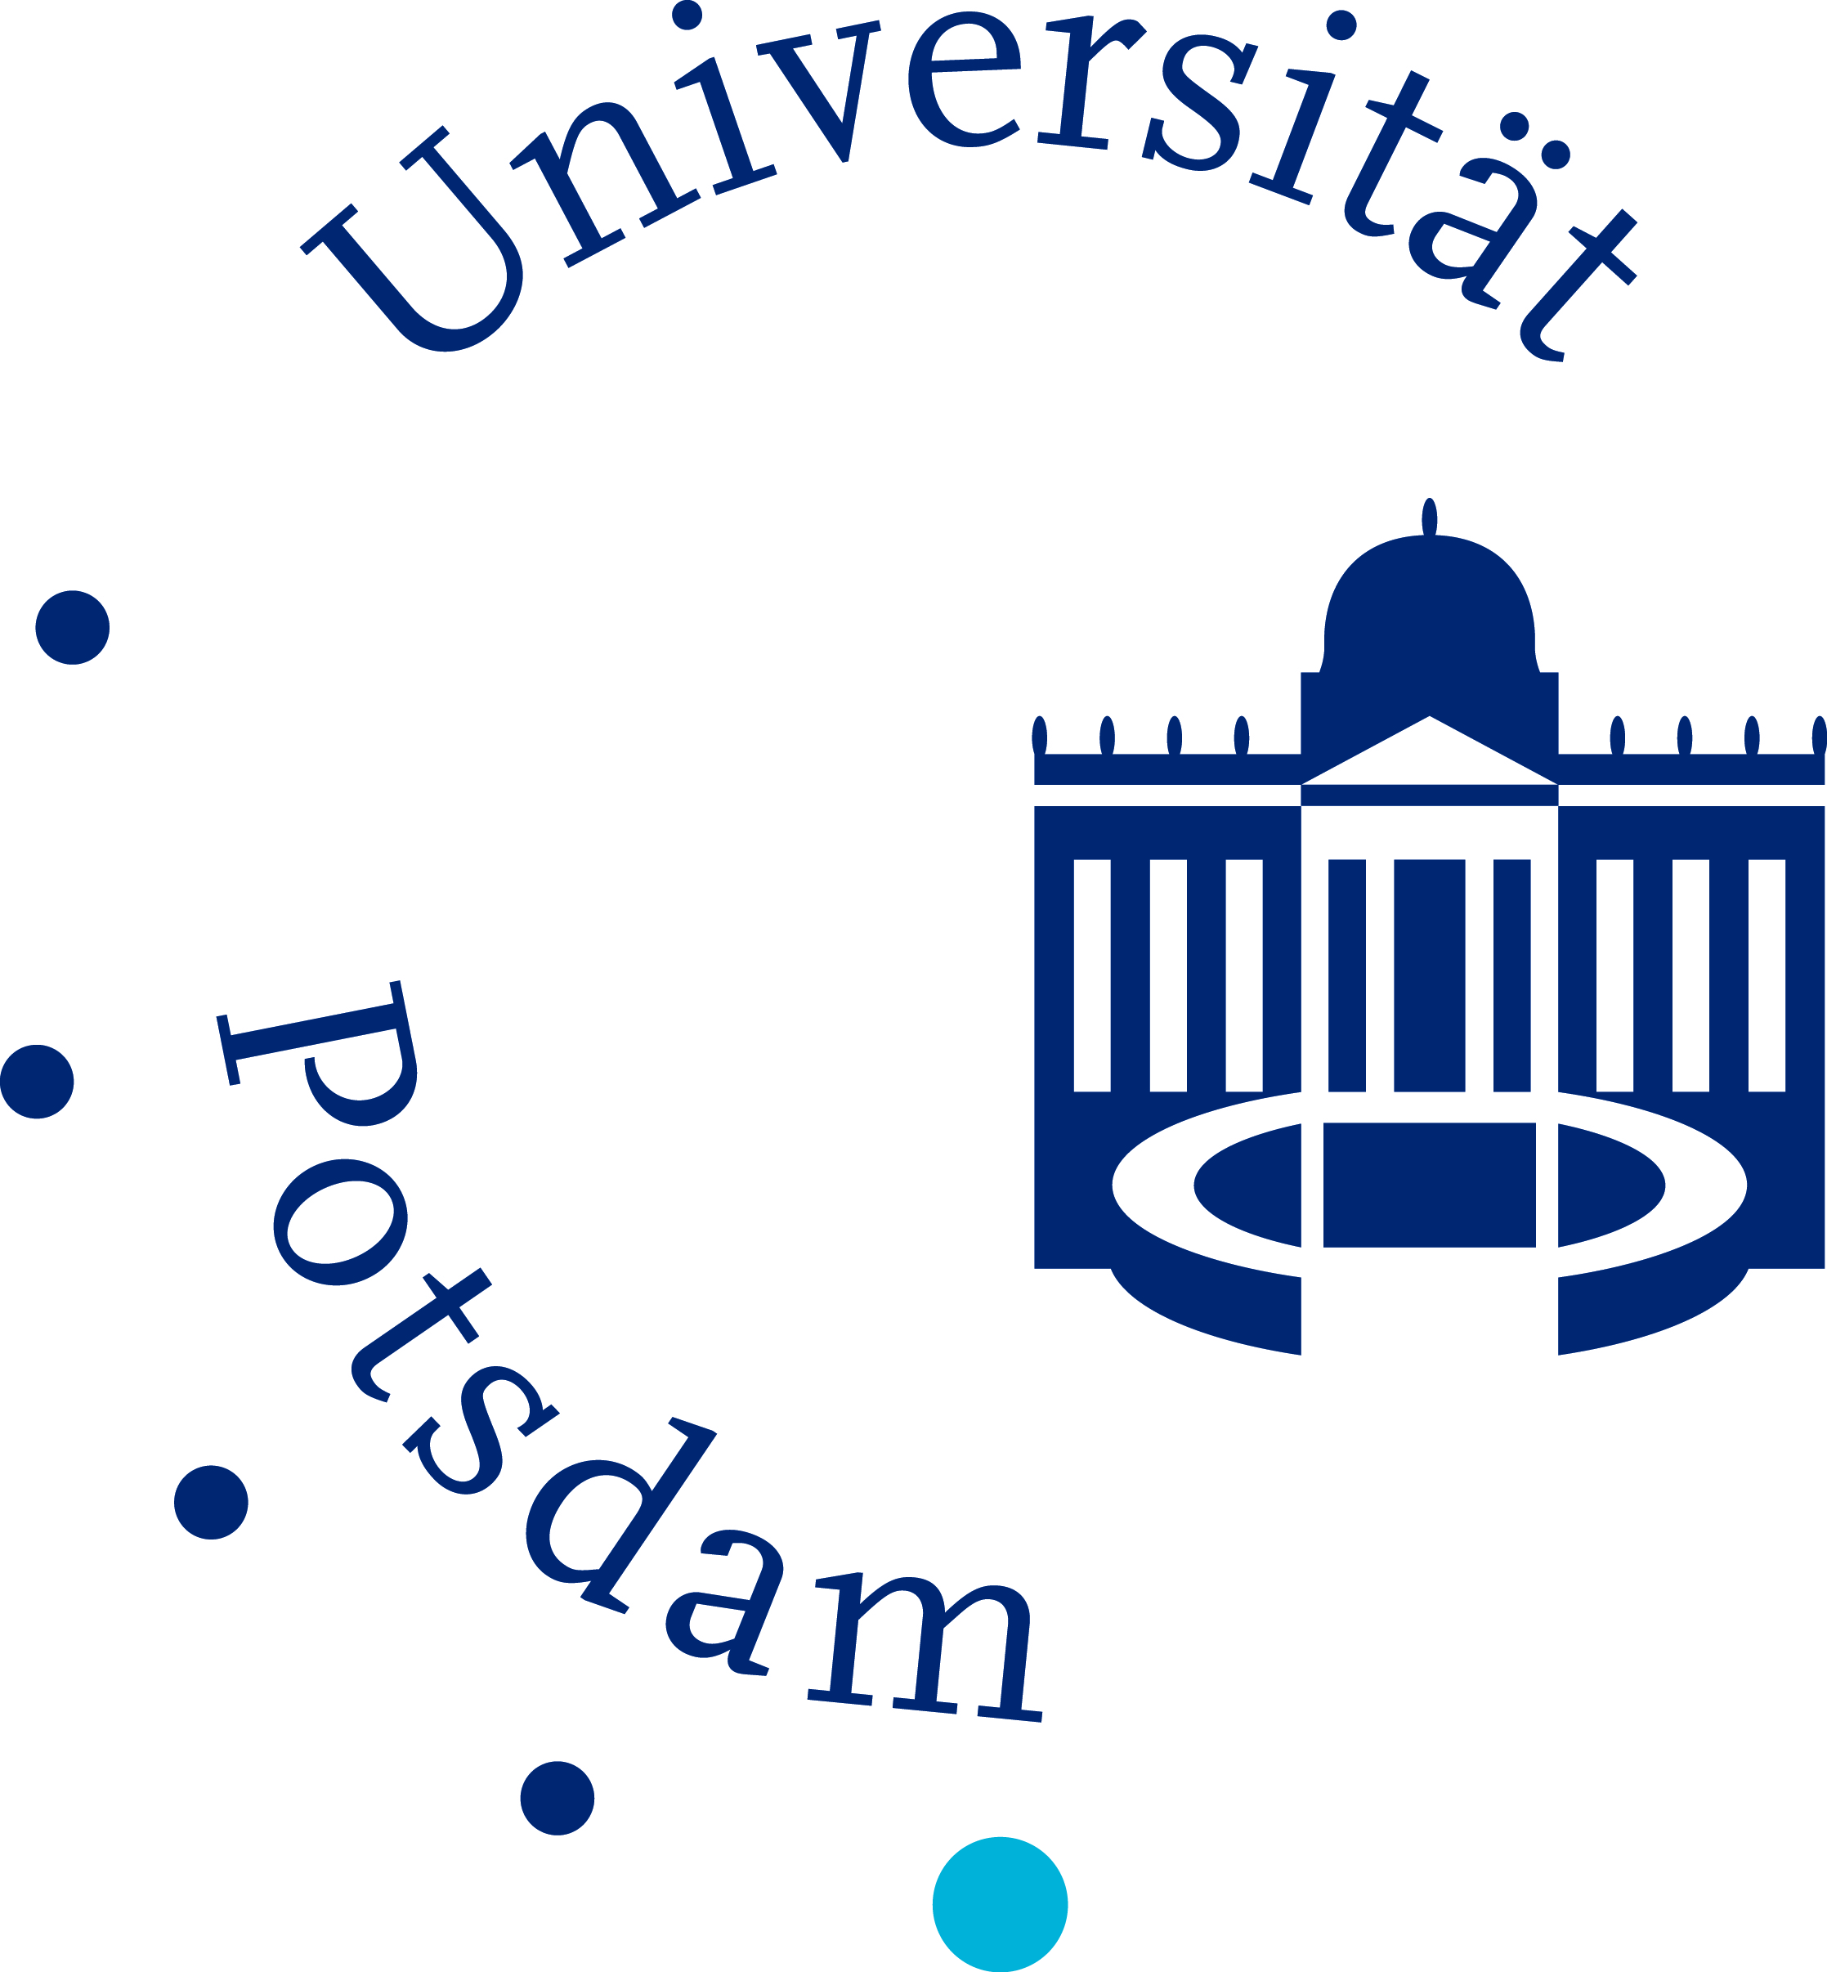

**__________________________________________________________________________**

Founded in 1991, the University of Potsdam has developed from a small institution of higher education into one of the leading middle-sized universities in Germany. The University benefits from a close cooperation with the whole range of renowned non-university research institutes in the proximity. The group of Microbiology invites applications of talented candidates to apply for the following position

**Doctoral Student (w/m/d) Harnessing spatial metabolomic patterns to exploit cyanobacteria as productive biofilms**

for three years initially (starting date 01.07.2025). The project is part of the DFG priority program SPP 2494 “Productive Biofilm Systems”.

**Project background:**

Filamentous cyanobacteria of the genus *Nostoc* have many properties that are particularly favorable for development as productive biofilm systems. The photoautotrophs have very good passive immobilization capabilities and have been shown to form high-density biofilms. Both the multicellularity and the proven phenotypic plasticity can be used for an efficient spatial division of labor. *Nostoc* monocultures and mixed cultures can be genetically manipulated and have already been used for high-titer production of the heterologous compounds. In the project, we would like to develop Nostoc as a sustainable biofilm platform for the production of fine chemicals, guided by spatial metabolomic analysis and explore the mechanisms underlying phenotypic plasticity of *Nostoc*.

**Requirements:**

* a Master (or equivalent) in microbiology, biotechnology or molecular biology, preferably with experience and interest in one or more of the following: physiology of microorganisms, white or green biotechnology, chemical analytics
* Candidates about to earn their Master degree are welcome to apply.
* desirable methodological skills: molecular biology techniques, chemical analytics, enzymology
* High motivation, creativity and a cooperative personality

**What is offered:**

* PhD position for three years according to German public service pay scale
* Mentoring for young researchers
* Working in a young team of motivated scientists
* Living in the exciting urban area of Berlin-Potsdam

**How to apply:**

Applications including cover letter (providing motivation and research interests), curriculum vitae, and the names of two referees should be sent by 15th May 2025 by email to editt@uni-potsdam.de.