Basics In Moodle

How to upload simple Documents:
- Click on “Turn editing on” (which you find top right corner of the entry page of your course)
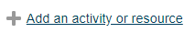
You can see your different sections (e.g. first on is named “Allgemeines”) which can be seen as your building blocks. Within each block you can add documents, or quizzes or similar. To do so:
- Scroll to the end of a section you want to edit and click “Add an activity or resource”
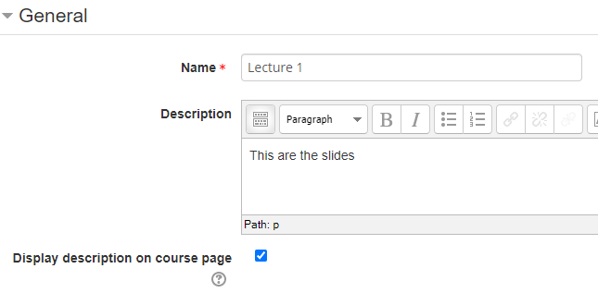
- Here you first have the choice of “Activities” and further down “Resources”; to add an pdf document scroll till you find “File”, select, on the right appears a short description, click “Add”
- Give the File a Name (this will be displayed)
- Optional add a description, if you want this displayed on the main page select “Display description on course page”
- Drag and Drop / Or search from your computer your desired File
- Optional change different settings regarding to eg restricted Access etc but no necessary, defaults are fine
- Click “Save and return to course”
- Done

