How to Do:

Creation of a short evaluation in Moodle
  - Quick Reference Guide:
For a short evaluation, the Moodle activity "Feedback" can be used. First, the activity is created and saved. After that, you can either design questions yourself with different question types or use templates provided by the faculty. For this you have to navigate to the tab "Templates". Note that the template can also be customized to your liking, for example, all questions can be marked as 'required' so that participants must answer all questions to complete the activity. The evaluation can be viewed directly under the 'Evaluation' tab or also downloaded as a table.
Note: The screenshots provided are in German, this was done on purpose as the Moodle Page translations are not complete. We hope that the description and the screenshots will help you in any case!

  - Detailed help: creation and settings of a short evaluation (at the end there are optional steps concerning the evaluation and a sample text for the description)
1. | Click on "Turn on editing” | 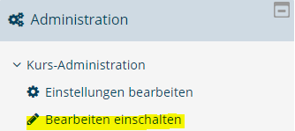
2. | Click "Create activity or material" in the section where you want to insert the short evaluation | 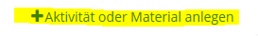
3. | elect the Feedback activity and click Add | 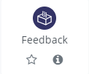
4. | Fill in the general settings of the feedback, like the name and a short description (example text see below). Check the box "Show description in course". | 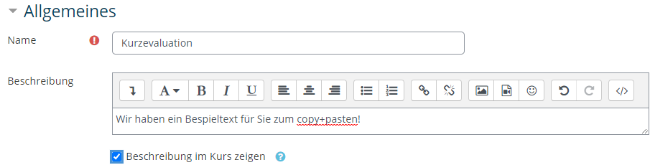
5. | Click "Save and view" to be able to edit the content
6. | You can now select a "Template" and/or "Edit elements". Note that elements of the template can also be edited. | 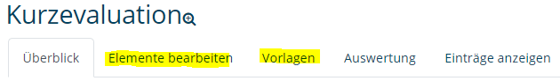
7. | (optional) Select Template and choose the template "Short Evaluation MathNatFak" under Public. | 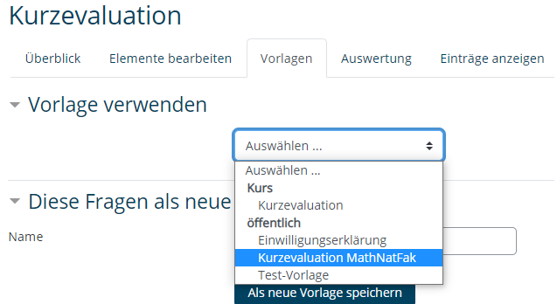
8. | (optional) You will now see an overview of the questions included in the template. Keep the preselection and click Save changes.  If you do not want to make any further changes, the creation is completed here. | 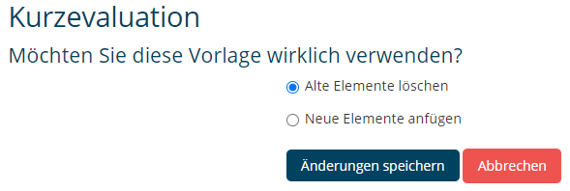
9. | Select the "Edit elements" tab. In the top drop-down menu you can select a question type. | 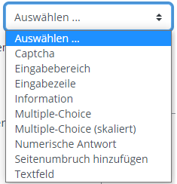
10. | Clicking on a question type - opens the editing options. The Feedback activity can now be filled as desired. If you do not want to make any further changes, the creation is completed here. | 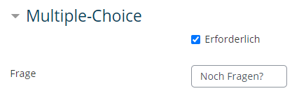

  - Detailed help: Evaluating a short evaluation and displaying individual entries
1. | Click on the "Evaluation" tab | 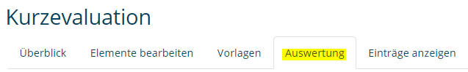
2. | You will now see an evaluation of the completed feedbacks. With a click on "Export to Excel" you can save the results as Excel file | 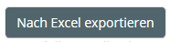
3. | In the window that opens, click "Save file" and confirm your selection by clicking "OK". (The view shown here may differ as it is browser specific). | 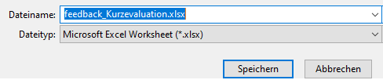
4. | (optional) By clicking on the tab "Show entries" you can view individual responses / feedback - these are anonymous and cannot be assigned to any participant.

Appendix: Example text for description
Dear students, please leave me a short evaluation about the course via this feedback. The evaluation consists of five short questions that take about three minutes to answer. The results will be collected anonymously and will help to further improve the course. I will then discuss the results of the evaluation with you in the course. Thank you for your feedback.

