How to Do:

Create questions - general & question type specific
  - Quick guide:
In Moodle there is the possibility to add a test as an activity. This must first be named and can be further characterized by access restrictions or time limits. After clicking on "Save and view" > "Edit test content" > "Add"> "New question" you can now choose from 22 different question types. How to handle each question type is explained in the detailed help (examples are given). The question types are sorted alphabetically.

Created questions can be assigned to question collections, so that you can, for example, reuse them or randomly select from them to generate different tests.
Note: The screenshots provided are in German, this was done on purpose as the Moodle Page translations are not complete. We hope that the description and the screenshots will help you in any case!

Detailed help: Create a simple question 2
All-or-nothing Multiple Choice 2
Calculated 3
Calculated multiple choice 5
CorrectWriting 5
Drag-and-drop on image 7
Drag-and-drop on text 8
Simply calculated 9
Free text 10
Short answer 11
Cloze 12
Cloze text selection 13
Multiple True / False 14
Multiple-Choice 15
Pattern matching 15
Pattern matching with Java Molecular Editor 16
Numeric 17
Stack 18
True/False 19
Random short answer assignment 20
Assignment 20

Detailed help: Create a simple question
1. | Click on "Enable editing" in the "Administration" navigation panel (on the right) | 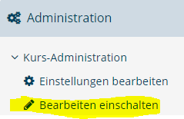
2. | Scroll to the end of the block where you want to add the test. Click on "Create activity or material" here | 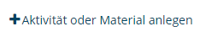
3. | Select "Test". In the settings window that now opens, at least one name must be specified. Other settings can also be made here. | 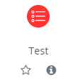
4. | Scroll down, click "Save and View" to complete the creation of a test. | 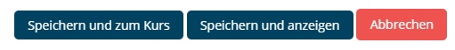
5. | Click "Edit test content" in the created test to add questions | 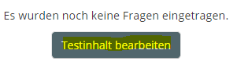
6. | Click (on the right) on "add". You have several options. If you want to create a new question click on "New question". | 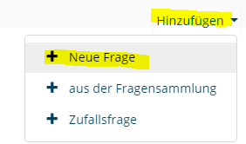
7. | Now you have the choice of different question types. When you select one, you will get a short description of the type. Below in the document are shown examples of how certain question types are created. | 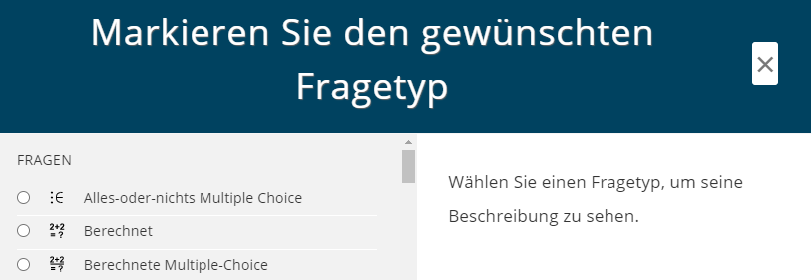
8. | For all questions, a question title, the question text and the achievable points must be entered.

All-or-nothing Multiple Choice
1. | Here you only have to enter different answer options in the fields provided for this purpose.
2. | Correct answers marked with a tick at "Correct" (multiple correct answers are possible - scoring is done according to the all or nothing principle) | 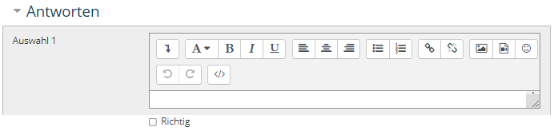
3. | (optional) Individual feedback can be given for each selection; under "Combined feedback", general feedback can be entered for correct or incorrect responses | 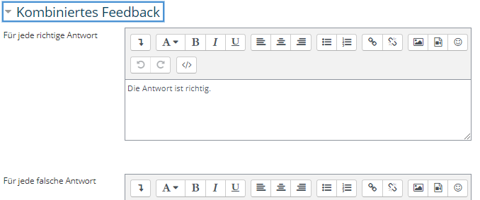

Calculated
1. | A question of the "Calculated" type works with variables, whose values are generated from so-called data sets.
2. | The variables are marked with "{...}", both in the question text and in the answer formula.  Here it is also possible to define permitted tolerances and desired decimal places. Especially the latter should be clearly recognizable for the test participants (e.g. insert in the question text: "to the second decimal place"). | 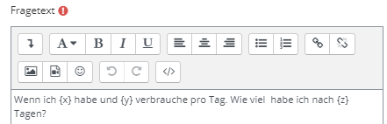  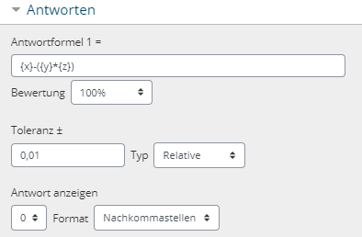
3. | With click on "Save changes" , the settings, as usual, are not yet finished! The specification of the value ranges of the variables follows. | 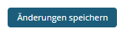
4. | All substitute characters are checked whether they only appear in the question or whether they are used in the answer formula.  For each replacement character (variable) it must be specified whether the final value is to be used from a private or shared data set.  In general, shared datasets are less work since multiple variables can access them. Once set up, other questions and their variables can also access these datasets. A disadvantage could be a possible confusion, if a lot of datasets are created 'globally'. | 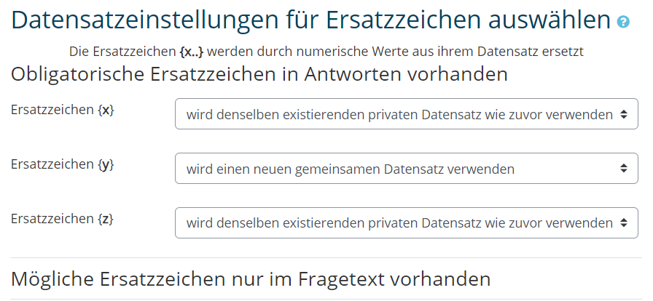
4. | If shared records are to be used, and they may be adjusted in the future, or are to be adjusted now, it is important to synchronize the records. For a better overview, the option "Show and synchronize shared record titles as prefix before question title" can also be selected. | 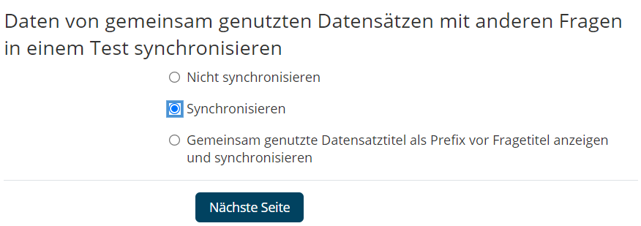
5. | On the next page, you can now select value ranges, decimal places and distributions. Under Response Tolerances, an example and its value are displayed.  With these parameters, so-called objects are added, which are nothing more than pairs of numbers. If you choose e.g. 10, 10 variants will be created for the question, after clicking on Add. (Attention: if nothing happens here check under answer tolerances if the correct answer is within the limits of the true value). | 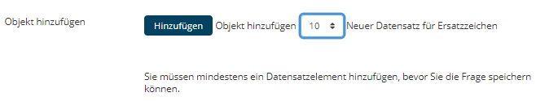
6. | After creating and displaying the data sets, you can now manually change the number pairs or even delete a variation completely. Here you can pay particular attention that the difficulty level is comparable for all tasks.  With "Save changes" the question and generated data sets are saved. | 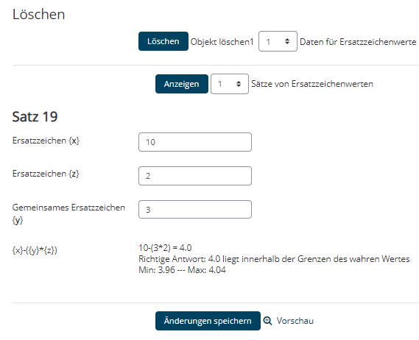

Calculated multiple choice
1. | This question type is particularly suitable if you want to present incorrect calculation methods or typical calculation errors as possible answers.
2. | Creating is very similar to the "Calculated" question type. The only difference is that multiple answer formulas must be given for multiple answer choices.  The sum of the "Rating" percentages must equal 100.  For the use of variables and data sets, see the "Calculated" question type. | 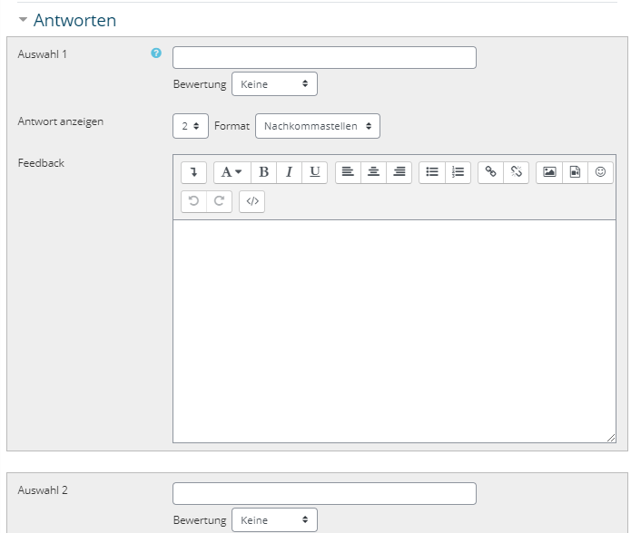

CorrectWriting
1. | This type of question identifies errors in a written sentence/word. Errors that can be detected and evaluated differently are e.g. missing letters or incorrect insertion of letters. Until now (as of 31.05.2021) only English, C and C++ are supported as languages.  One could use this question type for example to query an expected output of a C command chain.
2. | There are some options that can be specified, where the defaults (see right) specify a kind of "dictation": The words / tokens must be given in the correct spelling and in the correct order.  If you have questions about the options, you can get help by clicking on the blue question marks. | 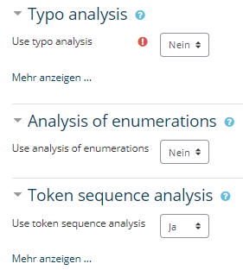
3. | (optional) "Hinting options" are used to give participants hints during the task, deducting points from them. Different types are possible. A value above 1 means that no hints are given after the first wrong answer (since no negative points are given).  The hints appear anyway, and in any case explain the participant his mistake. | 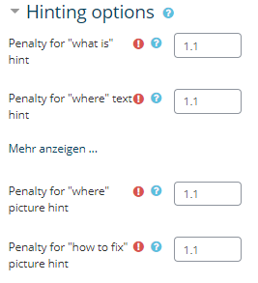
4. | Under the tab "Answers" you have to enter a description of the tokens/words in addition to the correct answer. This will be used for the error description / hints after the given answer.  Each token must be described with at least one space and at most one token (1 word, if the token is also 1 word). The tokens are created automatically (it may be necessary to save the changes first).  If spacebars are given as description, the tokens themselves are used (classically sufficient)

Drag-and-drop on image
1. | This question type allows placing text or small images on a background image. For example, one could have participants label a diagram with given words. Words not to be placed can also be given. Attention. This type is not suitable for people with visual impairment!
2. | Enter question title and question text. This must be given, even if the task is self-explanatory here. A suitable sentence would be:  "Place the given building blocks in the right place". | 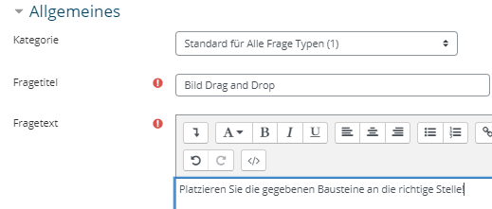
3. | Select your background image onto which the image or text blocks should be dragged. The image is uploaded directly as a preview and later still important. | 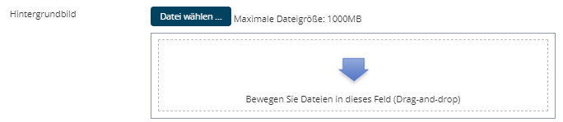
4. | Define the so-called "Movable elements", here you can choose whether they are text blocks or another unknown (image) type.  The group of elements is indicated to the participants (by color and shape). Make sure that not only one element per group is defined!  In the case of images, it is essential to ensure that they are of an appropriate size.  If movable images are desired, it is recommended to have the complete image available and to cut out the small building blocks directly (e.g. with the snipping tool), so that the sizes of the background image and the building blocks fit! | 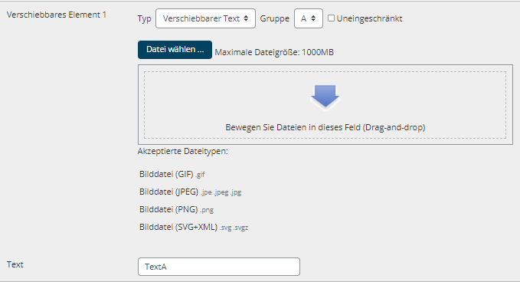
5. | After all moveable elements are defined, the drop zones are specified. For this purpose, either the coordinates can be specified or the individual elements can be placed correctly on the preview image (it is best to fold in the "Moveable elements" tab so that the preview image can be seen directly above the drop zones).  Select the movable elements and drag them to the desired position on the image. The coordinates will be updated automatically.

Drag-and-drop on text
1. | This type of question is a type of cloze, with the fill-in-the-blank (and also potential redundant fill-in-the-blank) given
2. | Title the question
3. | The question text is your cloze text. You specify and number the respective gaps with "[[x]]", where "x" is the number | 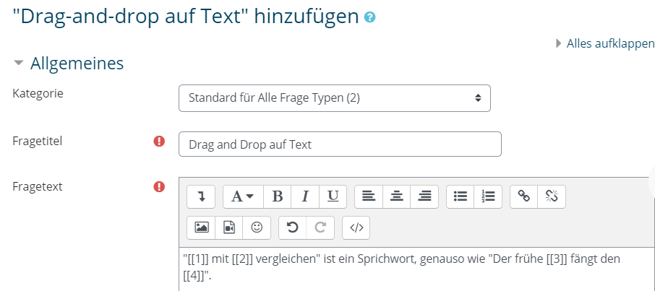
4. | You can now write the individual gap fillers under the "Selection" tab.You have the possibility to assign the gaps to individual groups, these are also recognizable for the participants.  Attention! Make sure that there are at least two gap fillers for each group, otherwise the selection is clear for the participants.  Caution. If you insert gap fillers in different places in your text, a check mark must be set for "Unlimited". | 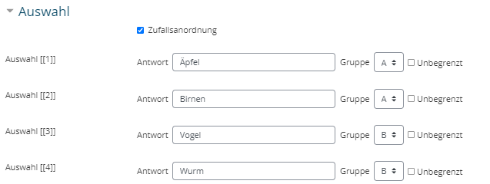

Simply calculated
1. | This question type is similar to the "Calculated" question type, but easier to create. Exchangeable values (variables) are randomly chosen from a list at each test call | 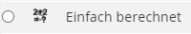
2. | Name your question
3. | Enter the question text. Exchangeable numeric values, i.e. your variables, are enclosed in curly brackets so that they are recognized as so-called "substitute characters". | 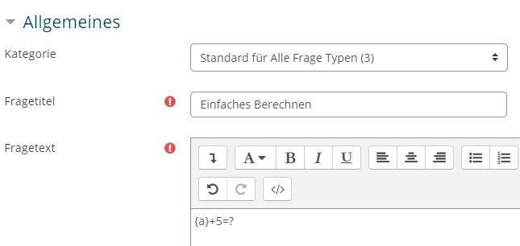
4. | Specify the answer formula and how many decimal places you want. Tolerances can also be allowed for this purpose.  Set the rating to 100%. | 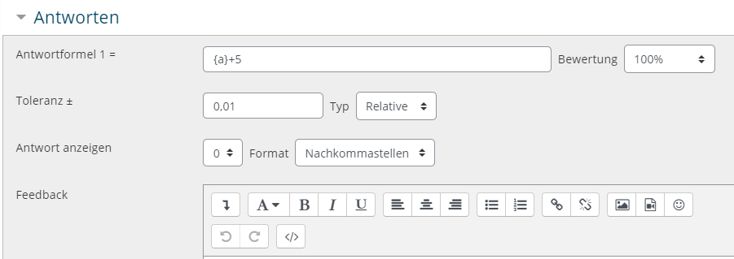
5. | Click on "Find replacement characters {x..} that appear in the correct answer formulas". | 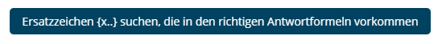
6. | After the page has reloaded, there is now the tab "Parameters for replacement characters to generate the values to be exchanged" (scroll down) | 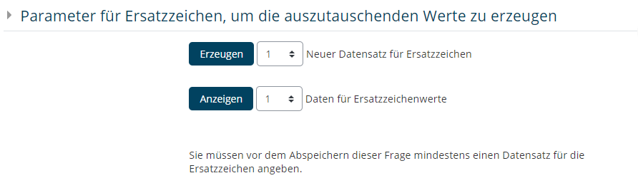
7. | Depending on how many variants you want of your question, that's how many records you need to create. Select the desired number and click on "Generate" | 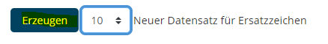
8. | (optional) By clicking on "Show" and then under the tab "Substitute character values">"Show more" you have the possibility to change individual records manually. | 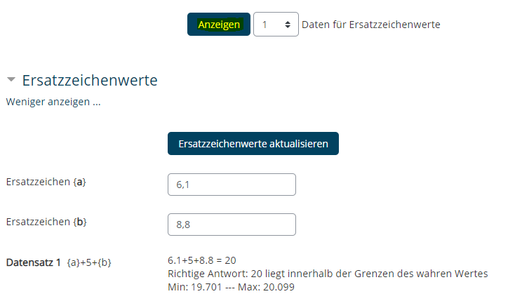
9. | Clicking on "Save change" completes the setup of this question type

Free text
1. | This question type allows any form of text or file responses as answers from participants.  Free text questions must be scored manually after submission.
2. | Title your question and enter a question text | 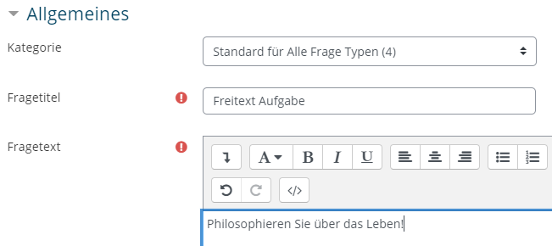
3. | Under the tab "Reply options" you can specify how much space should be given for the reply and if e.g. trailers are allowed. | 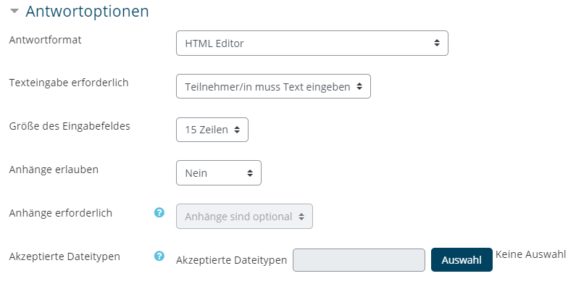
4. | (optional) If you do not rate the answers yourself or not alone, you can provide the raters with information about the question and their desired answer. | 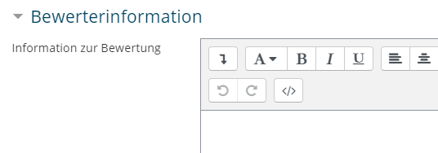

Short answer
1. | The question type "Short answer" expects a text answer, which is automatically evaluated by matching with sample answers.
2. | Title your question and write the question text. The question should be answered in as few words as possible (preferably one), this is the safest way for the automatic evaluation to work (with longer answers, for example, a different sentence structure can lead to a supposed "wrong" answer). | 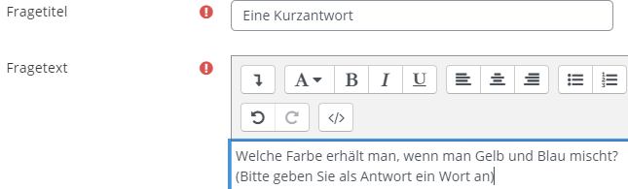
3. | (optional) Decide whether to be case sensitive under "Case sensitive". By default this is not the case.
4. | Enter at least one possible answer under the "Answers" tab and set its rating.  Pay attention to correct spelling and any typing errors! To make the sample answer more flexible, '*' can be used as a wildcard. A '*' stands for a character.  Useful for example when letters like "ä,ö,ü" are used, which are not available on all keyboards.  If there are several possible answers, several answers can be scored with 100%, so that the mention of one of these answers leads to the full score. | 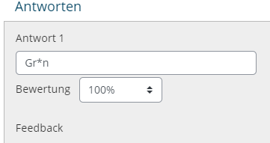

Cloze
1. | The Cloze type is very flexible and is suitable for combining several question types in a larger content context. Multiple choice, short answer and numeric type questions can be included. | 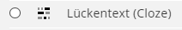
2. | Title your question.
3. | The question text is the heart of this question type. The different gaps are basically marked by '{}'. Within the gaps one specifies 3 parts: Rating, type of gap, answer options and marking the correct answer. Each part is delimited with ':'. More information about the three parts follows in points 4, 5 & 6. For a very detailed documentation, please have a look here (Moodle documentation). | 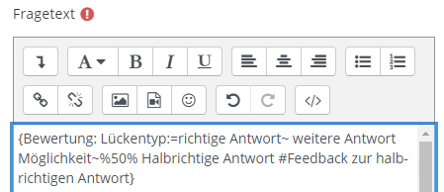  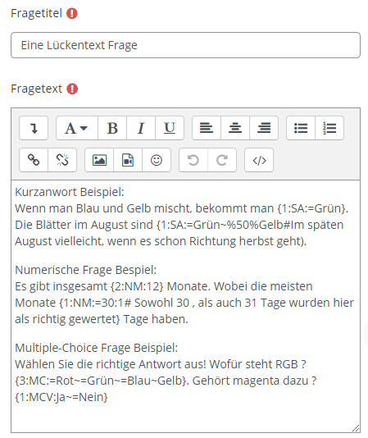
4. | The score is the first part of the gap and is a simple integer. The summed values of each gap gives the maximum score of the whole question/complete gap.
5. | The type of question and specific settings are determined with letter abbreviations (for all options see here):  - SA (short answer)  - SAC (short answer, case sensitive)  - NM (numerical answer)  - MC (multiple-choice, as a drop-down menu in the cloze text)  - MCV (multiple-choice, as radio buttons, arranged vertically)
6. | The answers are in the third part of the gap, with a preceding '=' marking the correct answer. Multiple answers are separated with '~'.  Each answer can be provided with feedback, which is marked by a preceding '#'.  For example, if you want to give half of the points for an answer, the answer can be prefixed with '%50%'.  Attention! There must always be at least one completely correct answer, which must be marked with '=' (two 50% answers are not possible).  For numeric questions, the answer can be provided with an error tolerance. This is separated with ':'.
7. | By clicking on "Decode and check question text" Moodle checks your entries for correct technical coding. Possible errors are indicated with red and the decoded questions can be checked by clicking on the respective tab. | 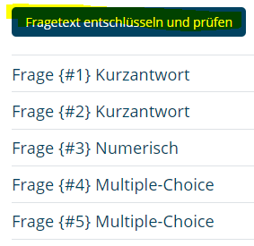

Cloze text selection
1. | This question type is similar to the cloze, where here the gaps are selected exclusively with answer options from drop-down menus. It is therefore limited in its flexibility, but somewhat easier to create. | 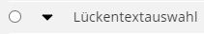
2. | Title your question. In the question text, specify your gaps with [[X]] where the 'X' is the respective numbering, i.e. [[1]] for the first gap, [[2]] for the second and so on. | 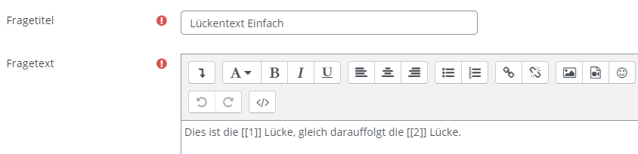
3. | Under the Selection tab, the correct answer must be entered in the right place. All terms belonging to the same group appear as answer options in the respective drop-down menu. | 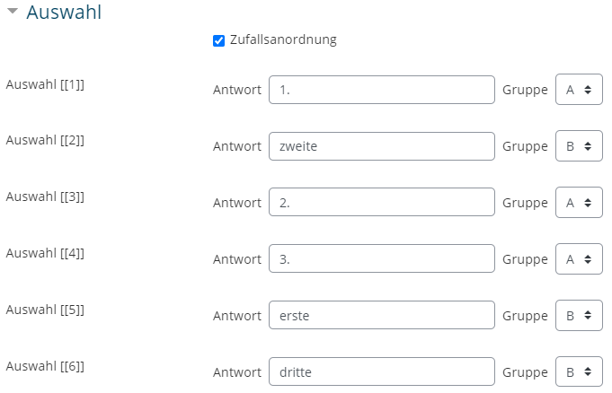

Multiple True / False
1. | Under this question type you can group several statements, each of which should be classified as "True" or "False" (in contrast to the question type "True/False"). Here it is possible to ask for any other binary assignment e.g. "yes/no", "left/right", "linear/square".
2. | Title your question and enter what is called the "stem" of the question here e.g. "Rate the following statements as True/False". | 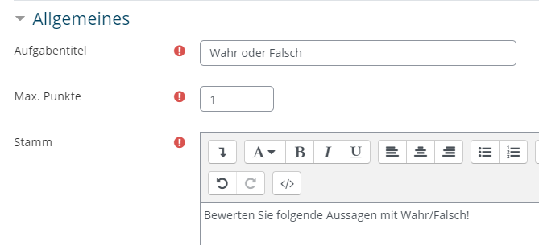
3. | Under the "Text and Feedback" tab, you can first specify the two groups to which the following statements/questions are to be assigned. By default this is "True/False" | 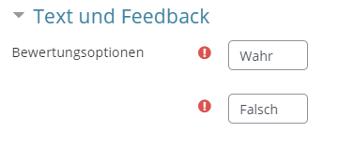
4. | Subsequently, in the "Text and feedback" tab, the question/statement can be asked in each case under "Optional answer" and the correct assignment can be selected by clicking on the respective radio button (right). Feedback can be added to each question.

Multiple-Choice
1. | The familiar question type where one or more answers can be selected. In contrast to the question type "All-or-nothing", partial points are possible here. | 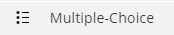
2. | Title your question and enter your question at the question text | 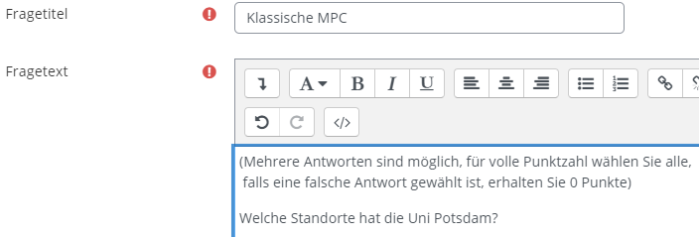
3. | Specify whether one or more answers are possible. You can also choose whether the answers should be mixed or numbered. It is possible to display standard statements | 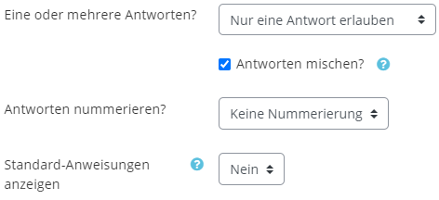
4. | Under the "Answers" tab, you can now enter your answers and determine the percentage of the answer for each evaluation. If two answers are correct and there are to be partial points, assign 50% each to the correct and -100% to the incorrect answer options. | 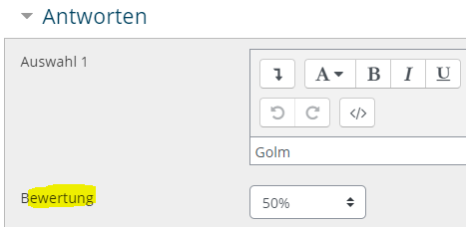

Pattern matching
1. | The pattern matching question type is very similar to the short answer type, whereas here more freedom of the pattern answer is possible through OU (Open University) pattern matching syntax. Thus even sentences or contained keywords and their order can be evaluated. | 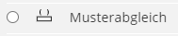
2. | Title your question and include the question text. | 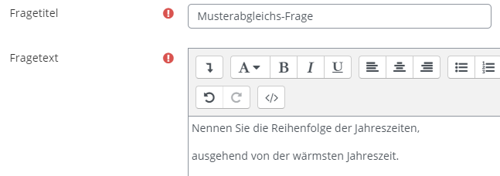
3. | (optional) Under the "Answer options" tab you can set options that specify the answers and their matching, such as ignoring upper and lower case .  You can also specify a sample answer to clarify the desired syntax of the answer. This minimizes the risk that a correct answer is not recognized as such.
4. | At least one correct answer with pattern matching syntax must be described. The rule creation wizard can also be used for this purpose.  Basically words or word chains can be compared with "match_w([...])". If only the entirety of all correct comparisons leads to the correct answer, all comparisons must be included with a "match_all()".  For more possibilities and a more detailed description of the syntax see here. | 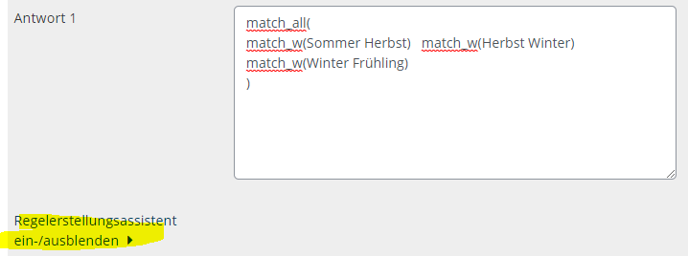

Pattern matching with Java Molecular Editor
1. | This question type allows the query of molecule structures. The matching takes place via the OU syntax and is oriented to SMILES.
2. | Title your question and enter your question text | 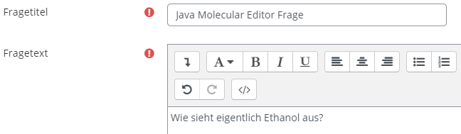
3. | You can enter your answer under the "Answers" tab. Use the pattern matching syntax. More about it here.  Attention. Brackets within the SMILES chain must be escaped with an '\'. | 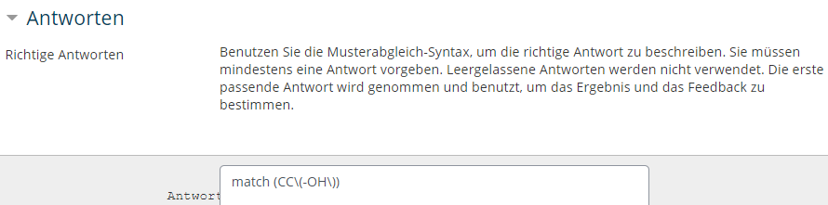
4. | Right is to see what the participants see | 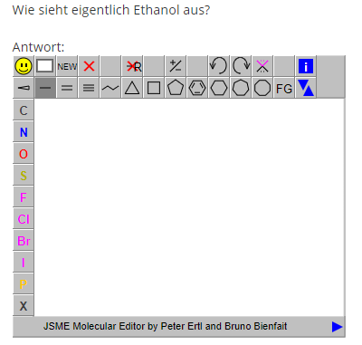

Numeric
1. | This question type asks for a numerical answer, which is compared to a given answer, in contrast to the question type "Calculated" or "Simply calculated". Tolerances can be taken into account here as well.
2. | Title your question and enter your question under "Question text" that asks for a numerical answer. | 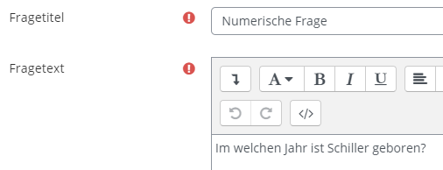
3. | Under the tab "Answers" you enter the answer, whereby errors (tolerances) can be allowed here. At least one rating must be set to 100%. | 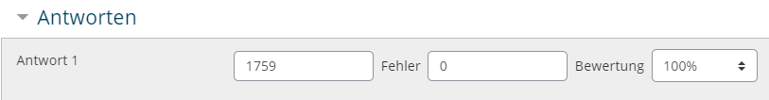
4. | (optional) It is also possible to assign values to measurement units. By default, measurement units are not used. If they are to be used, the tabs "Use of unit of measurement" as well as the tab "Units of measurement" must be observed. The displayed "question marks" offer a very good help in this case! | 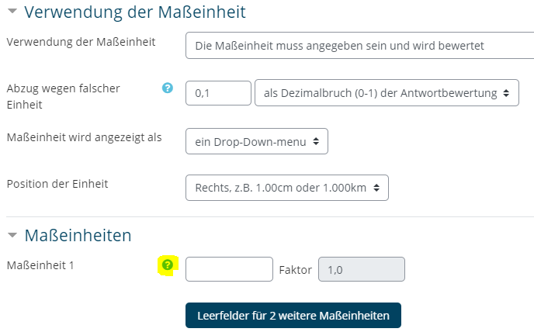

Stack
1. | The stack question type allows to resort to a computer algebra system (CAS) to determine and evaluate mathematical properties of the answers entered. A very simple example is shown below. It should be noted that the question type has a lot of potential for a wide variety of queries.
2. | Title your question. | 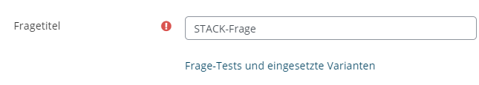
3. | (optional) Task variables, here you can define all the variables you want to use in the task. For more information see for example here.
4. | Latex syntax can be used in the question text, where inline-math is enclosed with '\( [...] \)' , display-math with '\[ [...] \]'. | 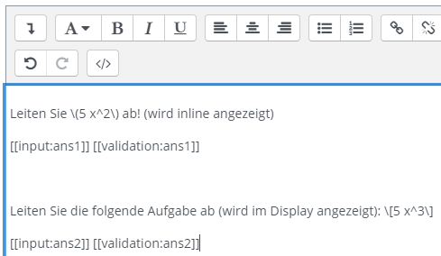
5. | By default, two text blocks are already defined in the question text window: the input of the participants is declared as ans1, and the validation of ans1 is also displayed.
6. | If you expect more than one answer, i.e. you deviate from the default, you must click on "Check the task text and update the fields". | 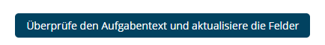
7. | Per expected input of the participant a tab appears under which some settings can be changed. The most important option is the input of the "sample solution".  For algebraic input, pay attention to the explicit '*' for multiplication. | 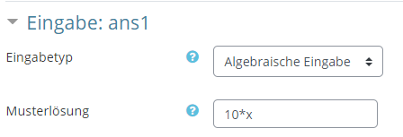  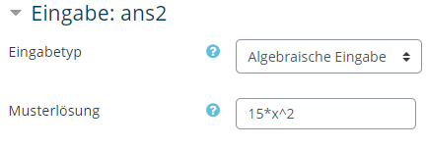
8. | The validation must also be specified, this is done under the tab "Feedback Tree (PRT): prt1", which consists of at least one node. The selection "AlgEquiv" specifies that Student-Answer (SAns) and Teacher-Answer (TAns) are checked for equivalence.  Attention - if you want to validate more than one input, the nodes must be connected. To do this, select the following node under "Next" in the window highlighted in green and red. | 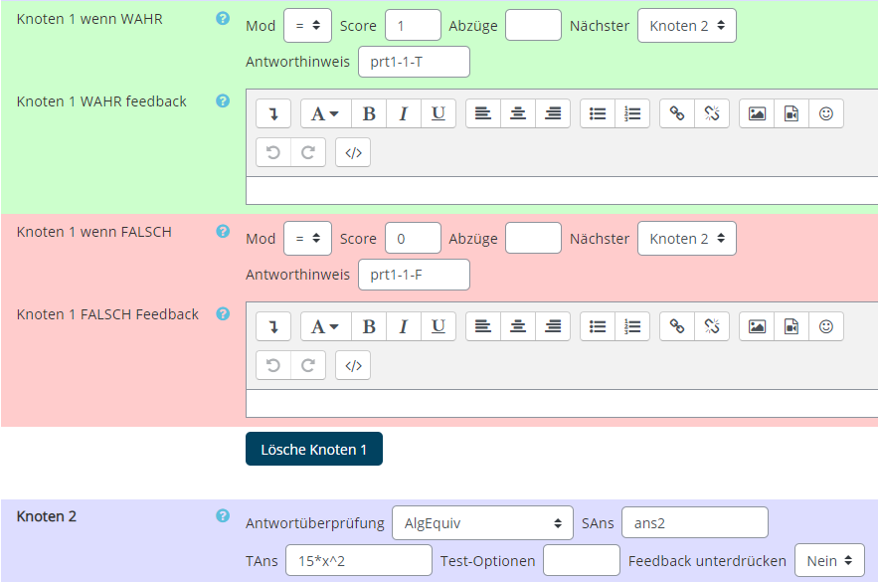

True/False
1. | The "True/False" question type is the simplest form of a multiple choice question. If you want to check several "True/False" statements, the question type "MTF (Multiple True False)" might be more suitable
2. | Title your question and enter the question/statement text to be scored/assigned. | 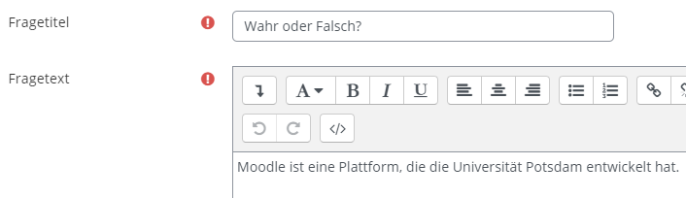
3. | Under the keyword "Positive evaluation for the answer" you enter the correct answer to the question. | 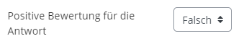
4. | (optional) Specific feedback can be given for the correct as well as the incorrect answer.

Random short answer assignment
1. | The participants do not see any difference between this question type and the question type "Assignment", however, the questions and answers that were created in the same category under the type "Short answer" are reused here. Possible use would be e.g. the repetition of all short answer questions of the previous semester.
2. | Title your question and enter your question text, which can explain the nature of the question here, for example. | 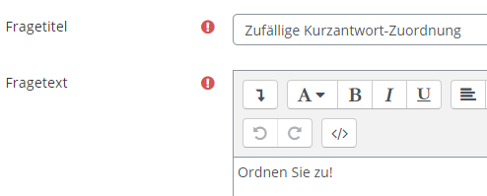
3. | The actual content of this assignment comes from previously created short answer questions and their answers. This can be accessed by the present question type only if the short answer type questions and answers are in the same category!  Check and if necessary change the selection under ("Save in category")  Attention! For this, the checkmark at "Use this category" must be deactivated. | 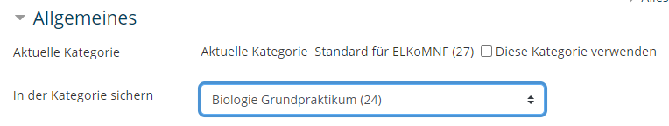

Assignment
1. | The question type allows you to request an assignment, choosing the options from a list. | 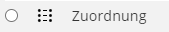
2. | Title your question and enter a question text. This can explain the question type, for example. | 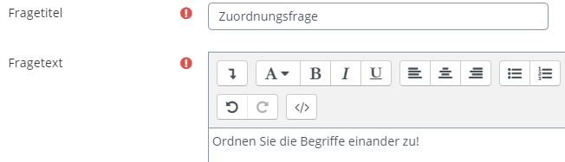
3. | The available choices can now be created under the "Answers" tab. There should be at least 2 questions and 3 answers available.  You can also leave questions blank and only enter something in the answer fields so that there are incorrect answer choices. | 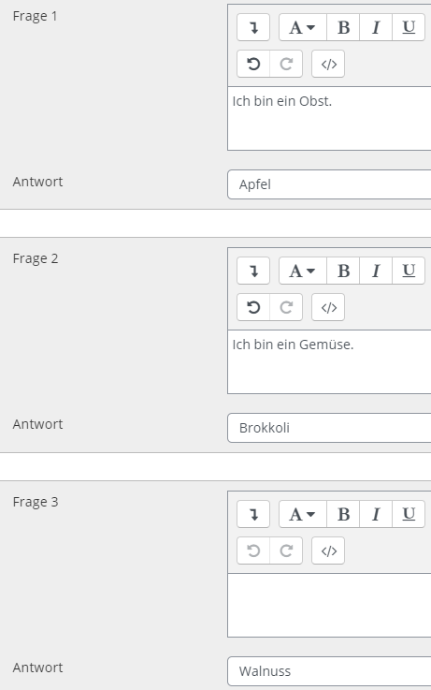
4. | In the final question, the possible answers are to be selected from a list.

