How to Do:

Basics with Excel

  - Brief instruction:
This Excel crash course will include the raw basics and an introduction on how to create and use charts. Excel and other spreadsheet based programs do have a lot in common and work a lot with icons and graphical support. They are built to be user-friendly while offering a wide variety of tools to analyse and display your data. For questions and further material please go to the official support sites or community based help-forums.

Note: if you do not have Excel yourself, you can get it based on a Campus License from the University of Potsdam. See here for instructions.

  - Basics – Cell Formatting
1. | There are several ways you can select data:  -Click on the first cell and drag to last or press “shift”, click on the last cell  -Click on the numbers on the right or letters at top to select entire row / column  Deselect cells by holding “ctrl” and clicking respective cells  Note: selected cells a darker then non selected cells | 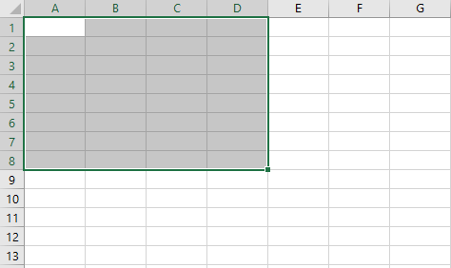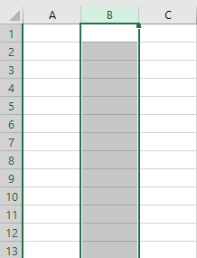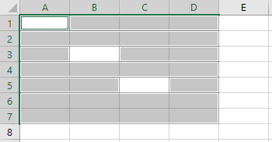
2. | Once selection you can e.g. color your data, or select border sizes

  - Basics – Basic Functions
1. | Excel has several functions that can be used to calculate given data. Choose an empty cell, click on the $f_{x}$ to see function Excel offers | 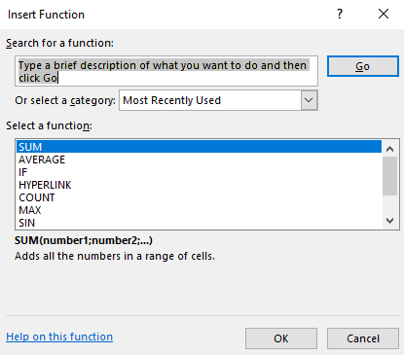
2. | Search for a specific function by either description or operations | 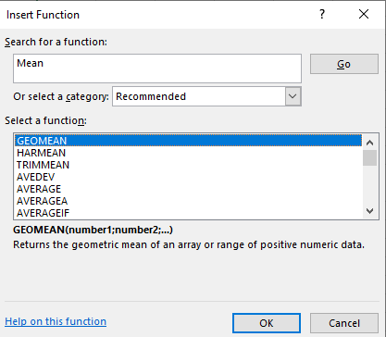
3. | (example) Calculate the average. Search for average (2.) and choose the cells you want to know the average from by clicking on the arrow
4. | (example) observe that if you change a value in chosen cells the average is updated | 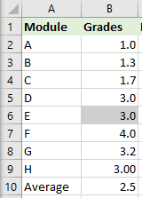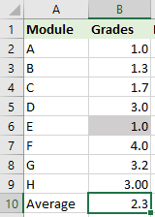
5. | You can also specify your own functions/ sequence of operations. Here you click on a cell and type in “=” | 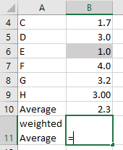
6. | Whenever you are in a cell that starts with “=” you can click on other cells to select that value for operations. Note: you can also select ranges of cells (click and drag) | 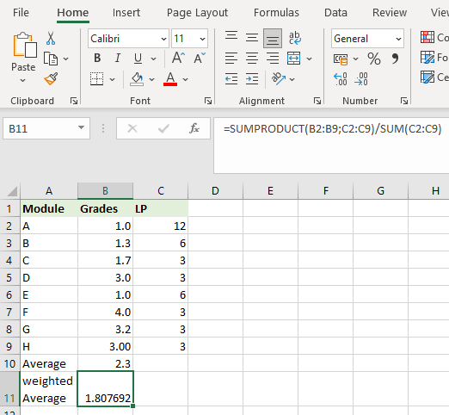

  - Charts
1. | Click on the “Insert” tab at the top of the window | 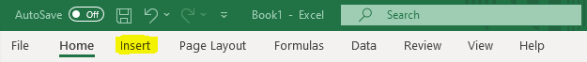
2. | Go to „Charts“ and choose a chart category and a specific plot
3. | Click on „Select Data“ to choose the data you want to add (Note that Excel may assume which data and how you want to plot this – this does not necessarily be the best or even right option, as shown here) | 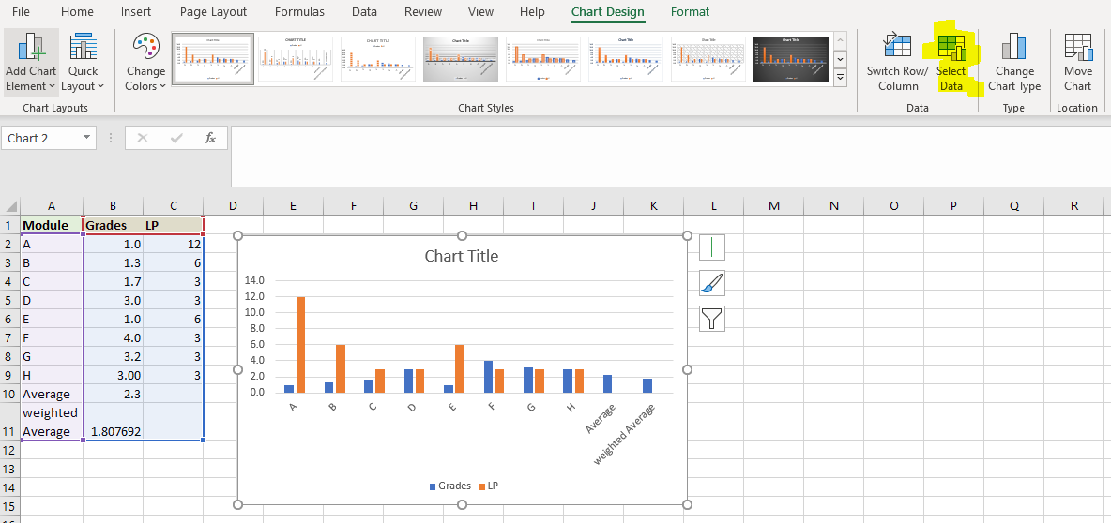
4. | (optional) To format the chart, click on “Add Chart Element” and choose the wanted element (Note: you can individually edit every added chart element)
5. | To export charts or plots to Word or PowerPoint click on the item and copy/paste | This was copy/pasted!

